TRACEABLE ARCHITECTURE PLANNING, RULE-CHECKED UML GENERATION AND COMPONENT-LEVEL UI DESIGN IN THE AUTOFORGE MULTI-AGENT PIPELINE
Individual Thesis
Sansala T.G.B.D.
IT22174826
Component: Architecture Planning and UI/UX Design Generation
Group ID: R26-SE-033
Thesis submitted in partial fulfilment of the requirements for the
Bachelor of Science (Honours) in Information Technology
Specialising in Software Engineering
Department of Software Engineering
Sri Lanka Institute of Information Technology
Sri Lanka
October 2026

DECLARATION AND SUPERVISOR CERTIFICATION
Candidate declaration. I declare that this thesis is my own work and does not incorporate, without acknowledgement, material previously submitted for a degree or diploma at any university or institute of higher learning. To the best of my knowledge, it contains no material previously published or written by another person except where acknowledgement is made in the text. I grant the Sri Lanka Institute of Information Technology the non-exclusive right to reproduce and distribute this thesis, in whole or in part, in print, electronic, or other media, while retaining the right to use the content in future work.
Academic integrity and AI disclosure. I have disclosed all use of generative AI and other automated tools in accordance with the module policy. I remain responsible for the accuracy, originality, citations, code, data, analyses, and conclusions in this thesis.
Student name | Student ID | Signature | Date
Sansala T.G.B.D. | IT22174826
Supervisor certification. The above candidate carried out this research for the bachelor's degree thesis under my supervision.
Role and name | Signature | Date
Supervisor: Nuwan Kodagoda
Co-supervisor: Eishan Weerasinghe
Abstract
In an LLM-based development pipeline, the design stages sit between an approved specification and the code. If the architecture plan misses a requirement, or a screen design shows something nobody asked for, the Coder Agent builds it anyway. This thesis covers the Architecture and UI/UX agents of AutoForge, a seven-agent, human-gated pipeline for e-commerce web development. The Architecture Agent produces a fifteen-section plan through a four-rung ladder: a read-only agentic exploration of earlier approved plans, a single-shot call, a JSON repair call and a deterministic fallback built from the SRS. A validator checks that every functional requirement, acceptance criterion, validation rule and non-functional requirement is traced. Use case, sequence and class diagrams come from narrow specifications that deterministic modelers normalise to UML rules before validators check them and PlantUML renders them. The UI/UX Agent plans pages and components, checks their coverage of the SRS, generates each component as an HTML and Tailwind fragment behind a placeholder check, and assembles self-contained previews. Shared design tokens change only after approval. I evaluated the work with 361 automated tests, the team's three-feature case study and stored artefacts. In the case study, the architecture and UI/UX stages both needed revisions that reviewers caught before code existed. The artefacts also show the limits of deterministic checking. A fallback plan passed full traceability while its data entity held fields such as "string" and "optional", because the Requirement Agent wrote "name: type" while the parser expected "name (details)". The UI/UX previews were complete and realistic, yet one enriched requirement had no page, and the two agents chose different routes. Traceability checks prove that something was planned, not that it was planned well, so human review of the design stages remains necessary.
Keywords: software architecture generation, UML, UI generation, human-in-the-loop, multi-agent systems, traceability
ACKNOWLEDGEMENTS
I would like to thank my supervisor, Nuwan Kodagoda, and my co-supervisor, Eishan Weerasinghe, for their guidance throughout this project. Their questions about how we would know whether a generated diagram was actually correct pushed me to look past whether the output was well formed.
I am grateful to my teammates, Santhuka D.N.M.D., Dissanayake T.C. and Oberathna R.D.T.D. The specifications from the first stages were the input to my agents, and the Coder Agent was the first real consumer of the plans and page designs they produced. Many of the fixes described in this thesis began as a problem one of them found at the boundary between our components.
I also thank the academic staff of the Department of Software Engineering at the Sri Lanka Institute of Information Technology, and the panel members at the progress presentations, for their feedback. Finally, I thank my family and friends for their patience and support during this project.
TABLE OF CONTENTS
Declaration and Supervisor Certification i
Abstract ii
Acknowledgements iii
Table of Contents iv
List of Figures vii
List of Tables viii
List of Abbreviations ix
1 INTRODUCTION 1
1.1 Overall Project Context 1
1.2 Individual Component Context 2
1.3 Problem Statement 3
1.4 Research Gap 4
1.5 Aim and Objectives 4
1.6 Research Questions 5
1.7 Scope, Limitations and Assumptions 5
1.8 Individual Contribution 6
1.9 Thesis Structure 6
2 LITERATURE REVIEW AND RELATED WORK 7
2.1 Review Method and Scope 7
2.2 Domain and Theoretical Foundations 7
2.2.1 Architecture plans and design views 7
2.2.2 UML diagrams 8
2.2.3 Traceability into design 8
2.2.4 Human oversight of agent plans 8
2.2.5 Design science 9
2.3 Related Research 9
2.4 Existing Systems, Products and Techniques 10
2.5 Gap Synthesis and Conceptual Framework 11
3 RESEARCH METHODOLOGY 12
3.1 Research Design 12
3.2 Data, Participants and Study Materials 12
3.3 Experimental and Study Procedure 13
3.4 Measures and Evaluation Metrics 14
3.5 Data Analysis 14
3.6 Ethics, Privacy, Security and Responsible AI 14
3.7 Reproducibility and Research Artefacts 15
4 PRODUCT AND SOLUTION DESIGN 16
4.1 Requirements 16
4.2 Component Architecture within the Complete Solution 17
4.3 Design Alternatives and Decisions 18
4.4 Detailed Design 19
4.4.1 Architecture plan structure 19
4.4.2 Generation ladder and coverage validation 20
4.4.3 UML diagram generation 21
4.4.4 Revision 23
4.4.5 UI/UX page and component design 23
4.4.6 Approval, cascades and the design system 25
4.5 Standards and Professional Practice 25
5 IMPLEMENTATION 27
5.1 Development Environment and Technology Stack 27
5.2 Implementation of the Core Modules 27
5.2.1 Architecture Agent 28
5.2.2 Diagram pipeline 29
5.2.3 UI/UX Agent 29
5.2.4 Interface support 30
5.3 Integration with the Complete Solution 30
5.4 Testing and Quality Assurance 31
5.5 Deployment and Operation 32
6 RESULTS AND EVALUATION 33
6.1 Component-Level Test Results 33
6.2 Experimental Results 34
6.2.1 Traceability of architecture plans (RQ1) 34
6.2.2 Quality of the generated UML diagrams (RQ2) 35
6.2.3 Completeness of the page designs (RQ3) 38
6.2.4 Human review at the design stages (RQ4) 40
6.3 Stakeholder and User Validation 40
6.4 Integration and Performance Results 41
6.5 Summary of Findings 41
7 DISCUSSION 43
7.1 Interpretation of the Results 43
7.2 Comparison with Related Work 44
7.3 Implications for Practice 44
7.4 Threats to Validity 45
7.5 Limitations 45
8 COMMERCIALISATION AND SUSTAINABILITY 46
8.1 Value of the Component 46
8.2 Target Users and Market Position 46
8.3 Business Model and Feasibility 47
8.4 Sustainability and Maintenance 47
8.5 Contribution to the Sustainable Development Goals 48
9 CONCLUSION AND FUTURE DIRECTIONS 49
9.1 Conclusion 49
9.2 Achievement of Objectives 49
9.3 Contribution 50
9.4 Future Directions 50
REFERENCES 51
GLOSSARY 53
APPENDICES 54
Appendix A: Supporting Technical Material 54
Appendix B: Disclosure of AI Tool Use 56
LIST OF FIGURES
Figure 1.1 The AutoForge pipeline, showing the seven agents, their outputs, human approval and feedback loops 2
Figure 2.1 Conceptual framework for the architecture and UI/UX component 11
Figure 4.1 The component's place in the complete AutoForge architecture 18
Figure 4.2 Architecture plan generation ladder and diagram pipeline 21
Figure 4.3 UI/UX Agent pipeline from metadata to approved design 24
Figure 6.1 Retail store sequence diagram, version 1, rendered from the agent's PlantUML source 36
Figure 6.2 Retail store class diagram, version 1, rendered from the agent's PlantUML source 37
Figure 6.3 Finodil Item Listing use case diagram before and after revision 38
Figure 6.4 Retail store page previews, version 1: Add Item (left) and List Items (right) 39
LIST OF TABLES
Table 2.1 Design-stage properties of related systems 10
Table 3.1 Features whose design artefacts are analysed 13
Table 3.2 Measures used for each research question 14
Table 3.3 Configuration parameters of the component 15
Table 4.1 Functional requirements of the component 16
Table 4.2 Non-functional requirements of the component 17
Table 4.3 Main design decisions 18
Table 4.4 Sections of the architecture plan 20
Table 4.5 Main UML rules checked by the diagram validators 22
Table 5.1 Technology stack used by the component 27
Table 5.2 Main modules of the component 27
Table 5.3 Automated tests for the component 31
Table 6.1 Key behaviours confirmed by automated tests 33
Table 6.2 Traceability matrix of the retail store plan, version 1 34
Table 6.3 SRS data requirements and the fields the fallback produced 35
Table 6.4 Issues in stored diagrams and whether they were flagged 35
Table 6.5 Gaps found in the retail store page design 39
Table 6.6 Pipeline with human gates on and off 40
Table 6.7 Execution performance of the full pipeline 41
Table 6.8 Summary of findings by research question 41
Table 8.1 Alternatives for producing a feature design 46
Table 9.1 Achievement of the objectives 49
Table A.1 Test files for the component 54
Table B.1 Use of generative AI tools 56
LIST OF ABBREVIATIONS
Abbreviation | Description
AC | Acceptance Criterion
AI | Artificial Intelligence
API | Application Programming Interface
CRUD | Create, Read, Update and Delete
CSS | Cascading Style Sheets
DTO | Data Transfer Object
FR | Functional Requirement
HTML | HyperText Markup Language
JSON | JavaScript Object Notation
LLM | Large Language Model
NFR | Non-Functional Requirement
PNG | Portable Network Graphics
QA | Quality Assurance
RAG | Retrieval-Augmented Generation
REST | Representational State Transfer
RQ | Research Question
SDG | Sustainable Development Goal
SDLC | Software Development Life Cycle
SRS | Software Requirements Specification
UI | User Interface
UML | Unified Modeling Language
US | User Story
UX | User Experience
VR | Validation Rule

1 INTRODUCTION

1.1 Overall Project Context
AutoForge is our team's final-year research project: a multi-agent system that builds features of an e-commerce web application with large language models (LLMs). Instead of turning one prompt straight into code, it works in stages, much as a software team would. A Requirement Agent writes the Software Requirements Specification (SRS), a Domain Agent enriches it with domain knowledge, an Architecture Agent designs the solution, a UI/UX Agent designs the screens, a Coder Agent implements the change, and Security and Quality Assurance (QA) agents check the result. Every agent produces a versioned artefact, and a person can approve it, reject it or ask for changes before the next agent uses it.
Our research paper starts from the observation that an LLM can already write a working function or page on request, but a full application depends on a chain of design decisions. Tools that go from a prompt to code skip that chain, so when the result is wrong it is hard to tell whether the requirement, the design or the code was at fault. Multi-agent frameworks such as ChatDev [1] and MetaGPT [2] give agents separate roles, but their designs are agreed through agent conversation, not reviewed by a person as separate documents. Figure 1.1 shows the AutoForge pipeline as it appears in the paper.
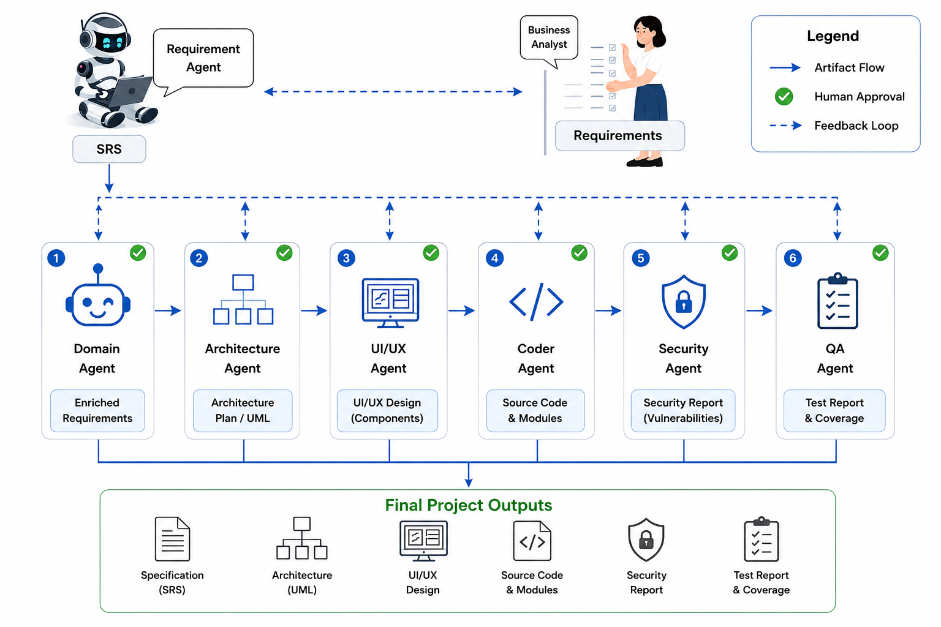
Figure 1.1: The AutoForge pipeline, showing the seven agents, their outputs, human approval and feedback loops
The project was split into four components, one per team member. My component is the design stage of the pipeline: the Architecture Agent, which produces an architecture plan and three UML diagrams, and the UI/UX Agent, which produces page designs that a reviewer can see and the Coder Agent can follow. The other components cover requirements and orchestration, code generation, and security and quality assurance. The team's common report describes the integrated system; this thesis describes my component in detail.

1.2 Individual Component Context
The design stages are where a specification turns into decisions a developer can act on: which endpoints exist, which data entities hold which fields, which classes and modules carry the logic, and which pages the user sees. In AutoForge, the Coder Agent does not invent this structure. It reads the approved architecture plan, including a file-level implementation plan, and the approved page designs, and builds what they describe. Whatever the design stages get wrong, the Coder Agent will faithfully implement.
This gives my component two audiences with different needs. The Coder Agent needs a plan that is complete and machine-readable: every requirement mapped to a design element, every endpoint with a method and a path, and every page with its components and content. The human reviewer needs something they can judge quickly: a readable plan, diagrams in a notation they already know, and screens they can look at rather than imagine. Much of the design work described in this thesis is about meeting both needs from the same artefacts.
Diagrams deserve a special mention. A Unified Modeling Language (UML) diagram is only useful if it follows UML conventions; a use case diagram whose actor is a database, or whose use case is half a sentence, is worse than no diagram, because it looks authoritative. Getting an LLM to produce diagrams that are not just syntactically valid PlantUML but also sensible UML turned out to be one of the hardest parts of the component.

1.3 Problem Statement
When an LLM produces a design from a specification, three problems appear. First, the design may silently leave out requirements, so a reviewer who does not check every line approves an incomplete plan. Second, generated diagrams are often valid in syntax but wrong in modelling: technical components appear as actors, one action is split into several use cases or several actions are merged into one, and non-functional requirements turn up as messages or classes. Third, generated user interfaces often look finished while showing placeholder content, such as "No data available", or a screen that the model never filled in, so the reviewer cannot judge the real design.
Behind all three is the same issue: a locally hosted model will sometimes return output that is incomplete, malformed or simply wrong, and the stage still has to produce something a person can review. The problem this thesis addresses is therefore: how can the architecture and UI/UX stages of an LLM-based pipeline produce designs that are traceable to the approved specification, follow UML and interface conventions, and can be reviewed and corrected by a person, even when the model's output is unreliable?

1.4 Research Gap
The systems reviewed in Chapter 2 point to a gap with three parts. MetaGPT [2] produces a design document and diagrams through role agents, but the design is checked by other agents rather than by a deterministic coverage check or a person, and the published work does not report how often the diagrams follow UML conventions. Coding agents such as SWE-agent [3] and OpenHands [4] start from a task that is already specified and designed, so the design step is outside their scope. Traceability research [5], [6] stresses the value of links from requirements into design, yet in the LLM systems we reviewed, links from requirement identifiers to design elements are not reported as a checked property of the output.
Human-in-the-loop work such as HULA [7] shows that engineers value reviewing an agent's plan before code is written. What is missing is a design stage that produces an architecture plan, diagrams and page designs as separate, reviewable artefacts, checks them against the specification with rules that do not depend on the model, and still gives the reviewer something useful when the model fails.

1.5 Aim and Objectives
The aim of this work is to design, implement and evaluate the Architecture and UI/UX agents of AutoForge, so that the designs the Coder Agent builds from are traceable, follow modelling conventions, and are approved by a person.
To reach this aim I set four objectives:
1. O1: Build an Architecture Agent that produces a structured architecture plan, including a file-level implementation plan for the Coder Agent, and checks that every requirement in the approved SRS is traced to the plan.
2. O2: Generate use case, sequence and class diagrams through narrow specifications, deterministic modelling and rule-based validation, and render them with PlantUML.
3. O3: Build a UI/UX Agent that plans pages and components, checks them against the SRS, generates each component with realistic content, and assembles previews a person can approve, while keeping a shared design system consistent across features.
4. O4: Evaluate the component through automated tests, the team's case study and the artefacts produced on real features, including where the checks fall short.

1.6 Research Questions
1. RQ1: Can deterministic coverage validation keep a generated architecture plan traceable to the approved SRS, and what does traceability fail to guarantee?
2. RQ2: Does generating diagrams through narrow specifications, deterministic modelers and UML rule validators produce conventional UML diagrams, and which errors remain?
3. RQ3: Does per-component generation with a content-quality gate and deterministic page assembly produce complete, reviewable page designs?
4. RQ4: Does human review at the architecture and UI/UX stages catch problems before code is written?

1.7 Scope, Limitations and Assumptions
The work covers the architecture and UI/UX stages for single features of e-commerce web applications whose target stack is the one the Coder Agent generates: a Next.js App Router front end in TypeScript with MongoDB persistence. The architecture plan is a feature-level plan, not a full system architecture, and the diagrams are limited to use case, sequence and class diagrams. The UI/UX Agent produces static HTML and Tailwind CSS designs with realistic example content; it does not produce working interface code, which is the Coder Agent's job.
The evaluation is limited in scale. The team's case study covers three features, and the detailed artefact analysis in Chapter 6 uses features from two projects. This is enough to show how the mechanisms behave on real input, including their failures, but not to give rates with statistical confidence. Diagram quality was judged by inspection against UML conventions rather than by an independent panel.
I assume that the SRS reaching my agents has been approved by a person, and that a reviewer with some knowledge of software design is available to approve or revise each plan and page design.

1.8 Individual Contribution
Within the team, my responsibility was the design stage. My contributions are:
• the Architecture Agent's plan structure, prompts and four-rung generation ladder, including the read-only exploration of earlier approved plans and the deterministic fallback;
• the architecture plan validator and the implementation plan that the Coder Agent builds from;
• the use case, sequence and class diagram pipeline: narrow specifications, deterministic modelers, UML rule validators with targeted repair, and PlantUML rendering;
• the UI/UX Agent: page and component metadata, the coverage validator, per-component HTML generation with a content-quality gate, page assembly, preview screenshots and the integration manifest;
• revision through targeted operations for both agents, and the approval cascades and design-system updates that follow a decision; and
• the automated tests for these modules, and my share of the team's evaluation and paper.

1.9 Thesis Structure
Chapter 2 reviews related work and builds a conceptual framework. Chapter 3 describes the research method. Chapter 4 presents the design of the two agents and the decisions behind it, and Chapter 5 covers implementation, integration and testing. Chapter 6 reports the results, including a close look at the artefacts produced for real features, and Chapter 7 discusses what they mean. Chapter 8 considers commercialisation and sustainability, and Chapter 9 concludes.

2 LITERATURE REVIEW AND RELATED WORK

2.1 Review Method and Scope
I began with two surveys: Hou et al.'s systematic review of LLMs for software engineering [8] and He, Treude and Lo's review of LLM-based multi-agent systems for software engineering [9]. From their references I narrowed the review to the work most relevant to the design stage: multi-agent systems that produce design documents, coding agents that consume a design, human oversight of agent plans, and traceability from requirements into design. Work on testing and security with LLMs [10], [11] was included for one specific lesson, explained in Section 2.3, about verifying model output.
The review shares its sources with the team's research paper. I did not attempt a full systematic review; the aim was to understand what existing systems do at the design stage precisely enough to design my component against the gap.

2.2 Domain and Theoretical Foundations

2.2.1 Architecture plans and design views
An architecture plan records the decisions that turn requirements into a buildable structure: the main modules and their responsibilities, the interfaces between them, the data they hold, how they behave in normal and error cases, and how quality requirements such as security and performance are met. A common way to organise such a plan is through views, each answering one kind of question for one kind of reader. I used this idea directly: the AutoForge plan has eight design views, from a context view to a quality-attributes view, so a reviewer can find a particular kind of decision without reading the whole document.
For an agent pipeline, an architecture plan has a second reader, the Coder Agent. A human developer can fill gaps from experience; a coding agent will either guess or stop. So the plan needs a part written for the machine: an ordered list of files to create, the endpoints each implements and the data models they use.

2.2.2 UML diagrams
The Unified Modeling Language provides standard notations for describing software. This component uses three of them. A use case diagram shows who uses the system (actors) and for what goals (use cases), with include and extend relationships for mandatory and optional behaviour. A sequence diagram shows how participants exchange messages over time for one scenario, with fragments for alternatives and options. A class diagram shows the structural elements and their relationships. Each notation has conventions that make it readable: actors are people or external systems, not databases; a use case is a goal, not a step or a sentence fragment; a class is a structural element, not a requirement. These conventions are what my validators check.

2.2.3 Traceability into design
Gotel and Finkelstein [5] defined requirements traceability as the ability to follow a requirement backwards to its origin and forwards into design and implementation. Mucha, Kaufmann and Riehle [6] found that most traceability solutions still address one narrow type of link. The link from requirement to design is the first forward link, and in an agent pipeline it can be checked mechanically, because every requirement in the SRS carries a stable identifier. If the plan's traceability matrix does not mention an identifier, the requirement has not been designed for.

2.2.4 Human oversight of agent plans
He, Treude and Lo [9] identify human-agent collaboration and the verifiability of agent output as open problems for multi-agent software engineering. Takerngsaksiri et al. [7] report that engineers using HULA, a human-in-the-loop agent framework, valued the chance to review and correct the agent's plan before any code was written. A design stage with an approval gate applies the same idea to architecture and screens. Workflow frameworks such as LangGraph, which Pelluru [12] discusses for production multi-agent systems, make such pauses practical.

2.2.5 Design science
My work builds artefacts, two agents, and evaluates them in their intended setting. This places it within the design-science paradigm described by Hevner et al. [13], which asks that the artefact address a real problem, that it be evaluated rigorously, and that the research add knowledge about the design, including where it does not work.

2.3 Related Research
ChatDev [1] organises role-playing agents into a "virtual software company" that follows a waterfall-like process. Design happens in conversation between agents playing roles such as chief technology officer and programmer. The design is therefore implicit in the dialogue rather than a document a person can review on its own.
MetaGPT [2] is the closest published system to my component. Its role agents exchange structured documents, and its architect role produces a system design, including data structures and interface definitions and sequence diagrams in a text diagram notation, which the engineer role then implements. MetaGPT shows that structured design documents help coding agents. However, the design is reviewed by other agents, not by a person at a durable checkpoint, and the paper does not report a deterministic check that the design covers every requirement or that its diagrams follow UML conventions.
Many coding agents start from a task that is already specified. SWE-agent [3], OpenHands [4], CodeAct [14], HyperAgent [15] and Agentless [16] work on issues in existing repositories, typically evaluated on SWE-bench [17]. AgentCoder [18] adds test design and execution, and RepoCoder [19] retrieves code from the same repository to guide completion. These systems are strong once the design is settled; they do not produce the design. For AutoForge, they mark the boundary of my component: what I produce is the kind of input they assume.
RepoCoder's idea of using the existing repository as context is relevant in a different way. When a project already has approved features, a new feature's design should be consistent with them. This is the reason the Architecture Agent's first rung reads earlier approved plans, the project manifest and the existing workspace before planning.
Finally, surveys of LLMs in testing [10] and security [11] make a point that applies equally to design: most systems rely on the model's own judgement of its output rather than on an independent, deterministic check. For my component this suggested a clear division of work. The model proposes; ordinary code decides whether the proposal covers the SRS and follows the notation's rules.

2.4 Existing Systems, Products and Techniques
Table 2.1 compares the systems most relevant to the design stage on the properties my component is built around. N/R means the property is not reported in the publication.
Table 2.1: Design-stage properties of related systems
System | Design artefact | Coverage check against requirements | UML rule checks | Human gate on design
ChatDev [1] | Implicit in agent dialogue | N/R | N/R | N/R
MetaGPT [2] | System design document, interfaces, sequence diagrams | N/R | N/R | N/R
HULA [7] | Implementation plan | N/R | N/R | Yes (plan review)
SWE-agent / OpenHands [3], [4] | None (task given) | N/R | N/R | N/R
AutoForge (this work) | Plan with 8 views + implementation plan, 3 UML diagrams, page designs | Yes, deterministic | Yes, deterministic | Yes

Outside research systems, UI generation tools and design assistants can produce screens from a prompt, and diagram-as-code tools such as PlantUML make diagrams easy to generate and version. My component uses PlantUML for rendering, and Tailwind CSS for page designs, because both are text formats that an LLM can write and that render consistently. The techniques that are less common, and where most of my effort went, are the deterministic steps around the model: a coverage validator, UML modelers and validators, a content-quality check on generated screens, and page assembly in plain code.

2.5 Gap Synthesis and Conceptual Framework
The review shows a gap with three parts at the design stage: designs are not checked against every requirement by anything other than another model, generated diagrams are not checked against modelling conventions, and screen designs are not presented as separate artefacts that a person approves before implementation.
Figure 2.1 shows the conceptual framework I used. It connects three inputs (the approved specification, earlier approved designs in the same project, and the shared design system) through three generation mechanisms and three controls to three outcomes. As in the rest of AutoForge, the mechanisms produce content and the controls decide whether it may move forward; the human gate is the final control.
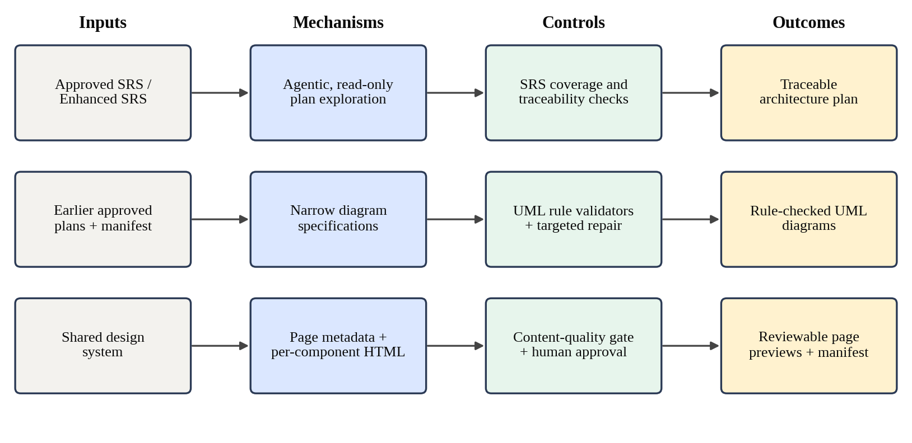
Figure 2.1: Conceptual framework for the architecture and UI/UX component

3 RESEARCH METHODOLOGY

3.1 Research Design
This is design-science research in the sense of Hevner et al. [13]. I built two artefacts, the Architecture Agent and the UI/UX Agent, to address the design-stage problem described in Chapter 1, and evaluated them in the pipeline they were built for. No shared benchmark exists for generating a feature-level architecture plan, UML diagrams and page designs from an approved SRS, so the evaluation combines automated tests of the deterministic parts, the team's pipeline case study, and a close reading of the artefacts the agents produced on real features.
Development followed build-and-evaluate cycles between June and August 2026. Each cycle changed one mechanism, tested it against hand-built fixtures, and then ran it on real features. Several design decisions came out of failures found in these runs, for example a use case named "Add List Items" that merged two goals, or a page preview that showed only "No data available". I report these failures as findings, because they explain why the design looks the way it does.
The artefact analysis in Chapter 6 deliberately includes weak outputs. A design stage is judged by what it does when the model's output is poor, not only when it is good, and the stored artefacts show both.

3.2 Data, Participants and Study Materials
The study materials were the approved specifications given to my agents, the models, and the artefacts the agents produced. Table 3.1 lists the features whose design artefacts are used in this thesis.
Table 3.1: Features whose design artefacts are analysed
Feature | Project | Source of evidence
Item Listing (CRUD) | Sample E-commerce | Team case study reported in the research paper
Authentication and Authorization | Sample E-commerce | Team case study (revision counts, QA, security)
Shopping Cart | Sample E-commerce | Team case study (revision counts, QA, security)
Item Listing | Finodil (development project) | Stored plan versions 1 and 2 with revision record
Add & List Items | Retail Store (development project) | Stored plan, PlantUML sources, page metadata, page previews

The default model was qwen3-coder served locally through Ollama, the same as for the rest of the pipeline. Some development runs of the UI/UX Agent used llama3, and observations from those runs are reported where they shaped the design. No external participants took part; reviewer decisions were made inside the project team, and no personal data was collected.
To show the diagrams exactly as the agent defined them, the figures in Chapter 6 were rendered from the PlantUML source files the agent saved, using PlantUML with Graphviz, the same renderer the agent uses.

3.3 Experimental and Study Procedure
Four procedures were used.
Component testing. The deterministic parts of both agents, the validators, modelers, patchers, page builder and approval cascades, were tested against hand-built fixtures with no model call. Parts that call a model were tested with stubbed responses, so that the fallback paths could be exercised on purpose, for example a model that never submits a plan or a call that times out.
Pipeline case study. As part of the team evaluation, each case-study feature was carried through all seven stages with human approval. For my stages, the team recorded the plan and diagram versions, the page design versions, the decision at each gate and the reason for each revision.
Artefact analysis. For the two development features, I examined every stored design artefact: the plan JSON, its human approval note, the three PlantUML sources, the page metadata, the integration manifest and the page previews. I compared each against the approved SRS and against UML conventions, and compared the two agents' outputs with each other.
Revision analysis. Where a feature had more than one plan version, I compared the versions and the revision record the agent stores, which lists the reviewer's comment, the changes applied and any requested changes that could not be matched.

3.4 Measures and Evaluation Metrics
Table 3.2: Measures used for each research question
RQ | Measure | How it is obtained
RQ1 | SRS identifiers traced; design views and sections present; coverage gaps found; quality of the traced content | Validator tests; traceability matrices of stored plans; inspection
RQ2 | UML rule violations detected and repaired; violations that remained in stored diagrams | Validator and modeler tests; inspection of PlantUML sources
RQ3 | Coverage of actors, UI expectations, stories and visible criteria; placeholder content; preview completeness | Validator and gate tests; stored metadata and previews
RQ4 | Revisions requested at the design stages and their causes | Case-study records; stored revision records

3.5 Data Analysis
The analysis is descriptive and partly qualitative. The number of features is small, so I report counts directly and do not compute rates or statistical tests. For the artefact analysis, each finding is tied to a specific stored file and, where possible, to the line of code that explains it. This made it possible to separate problems in the model's output from problems in my deterministic code, which matters because only the second kind can be fixed reliably.

3.6 Ethics, Privacy, Security and Responsible AI
The component uses the same locally hosted default model as the rest of AutoForge, so specifications and designs need not leave the machine. The Architecture Agent's exploration tools are read-only: they can list, read and search the project's workspace and earlier plans, but cannot change anything, and they are confined to the project's own workspace. The only tool that changes state is the one that submits the plan, and it only stores the submission for validation.
Page previews are made safe to open: the Tailwind script is embedded in the page rather than loaded from the internet, and every link in a preview is made inert, so a preview cannot navigate away or load outside content. Responsible use also means being honest with the reviewer. When validation finds issues the agent could not fix, they are written into the plan's human approval note in plain English rather than hidden, and the UI/UX Agent has no fallback that would invent a screen design when the model fails.

3.7 Reproducibility and Research Artefacts
All code, prompts, schemas and tests are in the team's shared repository, and every artefact is stored as a numbered version. Table 3.3 lists the settings that affect the results.
Table 3.3: Configuration parameters of the component
Parameter | Value
Default LLM | qwen3-coder via Ollama
Plan exploration turn limit | 80 steps
Diagram exploration turn limit (each) | 20 steps
Targeted repairs per diagram type | 2
UI metadata coverage repairs | Up to 4
Component content-quality repairs | Up to 2
Diagram renderer | PlantUML (Java) with Graphviz
Preview renderer | Playwright headless Chromium
Generated stack assumed | Next.js App Router, TypeScript, MongoDB

Model output is not deterministic, so a repeated run will not produce identical plans or pages. The validators, modelers, page assembly and approval behaviour are deterministic by design and give the same result for the same input.

4 PRODUCT AND SOLUTION DESIGN

4.1 Requirements
The requirements for my component came from the team's pipeline objectives, from what the Coder Agent needs in order to build a feature, and from problems found while testing on real features. Table 4.1 lists the functional requirements and Table 4.2 the non-functional ones.
Table 4.1: Functional requirements of the component
ID | Requirement
C2-FR-01 | Run only when an approved SRS exists, and use the approved Enhanced SRS instead when there is one
C2-FR-02 | Produce an architecture plan with fixed sections, eight design views and a traceability matrix
C2-FR-03 | Include a file-level implementation plan and implementation tasks for the Coder Agent
C2-FR-04 | Check that every FR, AC, VR and NFR identifier of the SRS appears in the plan's traceability matrix
C2-FR-05 | Take earlier approved plans of the same project into account when planning a new feature
C2-FR-06 | Generate use case, sequence and class diagrams, validate them against UML rules and render them as PNG
C2-FR-07 | Revise a plan by applying only the reviewer's requested changes, and report anything not matched
C2-FR-08 | Run the UI/UX stage only when the architecture plan is approved
C2-FR-09 | Plan pages and components that cover every actor, UI expectation, user story and screen-related acceptance criterion
C2-FR-10 | Generate each component with realistic content and assemble pages that open without a network connection
C2-FR-11 | Reuse approved components from earlier features instead of regenerating them
C2-FR-12 | Produce an integration manifest describing routes, navigation and components for the Coder Agent
C2-FR-13 | Update the project's shared design system only when a page design is approved
C2-FR-14 | Revise page designs, optionally limited to the pages the reviewer selects

Table 4.2: Non-functional requirements of the component
ID | Quality | Requirement
C2-NFR-01 | Reliability | A failed or malformed model response must never stop the architecture stage from producing a reviewable plan
C2-NFR-02 | Honesty | Issues the agent could not fix must be shown to the reviewer, not hidden
C2-NFR-03 | Generality | Validators and modelers must contain no feature-specific rules (no login, cart or payment cases)
C2-NFR-04 | Safety | Planning tools must be read-only; previews must not load or navigate to outside content
C2-NFR-05 | Consistency | Diagram names must agree with each other and features must share one design system
C2-NFR-06 | Testability | Deterministic logic must be testable without a model
C2-NFR-07 | Responsiveness | Both agents must stream progress to the interface during long runs

4.2 Component Architecture within the Complete Solution
Figure 4.1 places my component in the complete system. The orchestrator runs the Architecture Agent once the SRS, and the Enhanced SRS if there is one, have been approved, and runs the UI/UX Agent once the architecture plan has been approved. Both are hard gates: the pipeline stops after each until a person decides. The Architecture Agent uses PlantUML to render diagrams, and the UI/UX Agent uses Playwright to take preview screenshots. Both write versioned artefacts and read the project's cross-feature memory: the project manifest, which records the routes, endpoints and models built so far, and the design system, which records shared components and tokens.
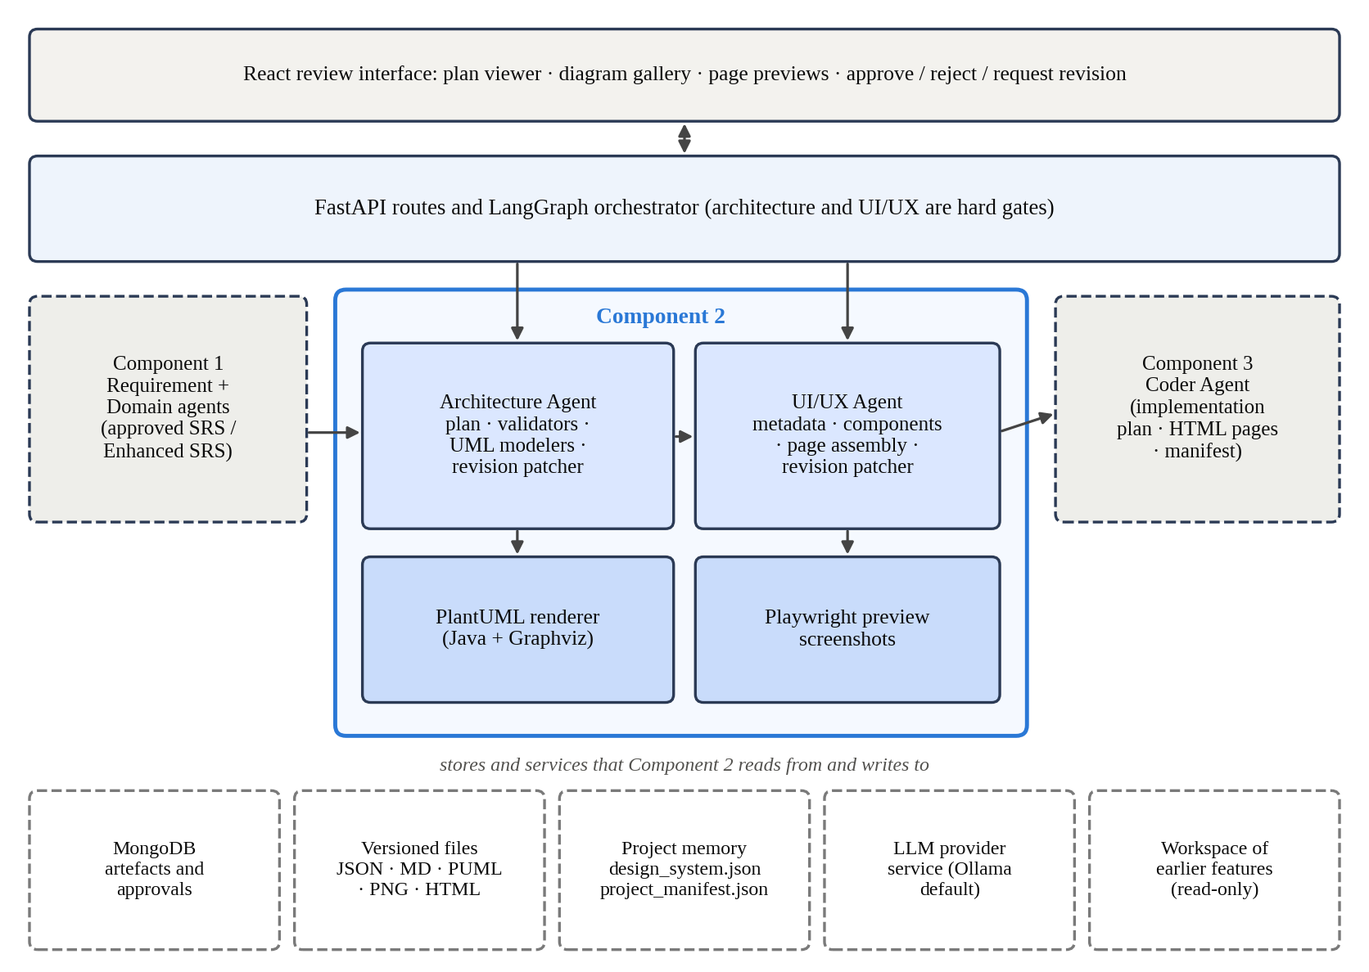
Figure 4.1: The component's place in the complete AutoForge architecture
The Coder Agent is the main consumer of my outputs. It reads the approved plan, in particular its implementation plan, and uses the approved page designs and the integration manifest as a visual and structural reference. The boundary is therefore the approved artefact, as elsewhere in AutoForge: neither of my agents calls the Coder Agent, and the Coder Agent never calls them.

4.3 Design Alternatives and Decisions
Table 4.3: Main design decisions
Decision | Alternative | Reason for the choice
Agentic, read-only exploration as the first rung | Single prompt with everything pasted in | Lets the model look up earlier plans and code only when it needs them; any failure falls back to the proven ladder
Deterministic SRS-derived fallback plan | Fail the stage when the model fails | The UI/UX and Coder stages are blocked until a plan exists; a reviewer can judge and revise a weak plan
Diagrams from narrow specifications + modelers | Model writes PlantUML directly | Valid PlantUML is not the same as sensible UML; modelers apply the rules every time
Sequence before class diagram | Generate both independently | The class step sees the finalised sequence names, so the two diagrams use the same names
Issues reported in the approval note | Block the run on any validator failure | Heuristic validators can be wrong; a person can judge a borderline case in seconds
No fallback for UI/UX | Template screens when the model fails | A guessed screen design misleads the reviewer more than an honest failure
Static HTML + Tailwind components | React components rendered in the preview | Static markup has no state branches that can fall into an empty or unknown state
Page assembly in plain code | Model writes the full page | Assembly cannot fail or invent content; one broken component can be regenerated alone
Design system updated on approval | Update after every run | A rejected design cannot change the look of later features

Two of these decisions were reversals. The first version of the UI/UX Agent generated React components and rendered them live in the preview. In a real run on the Item Listing feature, a page showed only "Unknown state." because the generated component handled three of its four declared states and the preview picked the fourth. Switching to static HTML with realistic content baked into the markup removed the whole class of problem, because there are no states left to pick from. The second reversal concerned revision. The Architecture Agent originally asked the model to retype the entire plan with the requested change; a stored plan's revision record showed that a parse failure had made the fallback copy the old plan unchanged, silently dropping the reviewer's request. Revision now uses targeted operations, as described in Section 4.4.4.

4.4 Detailed Design

4.4.1 Architecture plan structure
The architecture plan is a JSON document with fifteen required sections, listed in Table 4.4, plus an implementation plan. The eight design views each answer one kind of question, which keeps a long plan navigable for a reviewer. The plan is also converted to Markdown and to a PDF for reading.
Table 4.4: Sections of the architecture plan
Group | Sections
Context | document_control, feature_overview, requirement_interpretation, architecture_approach
Design views | context, logical, interface, data, behaviour, error handling, security and authorisation, quality attributes
Delivery | frontend_architecture_plan, backend_architecture_plan, validation_plan, coder_implementation_tasks, implementation_plan
Links | traceability_matrix (one row per SRS identifier and other traced item)
Risk and review | assumptions, constraints, risks, dependencies, human_approval_note

The implementation plan is written for the Coder Agent. It lists the back-end files with the endpoints each implements, the data models with their fields, the front-end pages and the services they call, and an ordered list of steps. File paths follow the conventions the Coder Agent's own planner uses for a Next.js App Router project, such as app/api/items/route.ts for a Route Handler, and a collection endpoint and an item endpoint always map to separate files because Next.js routes by folder. When the model leaves the implementation plan out, the agent derives one mechanically from the plan's own interface and data views, so every plan the Coder Agent receives has one.

4.4.2 Generation ladder and coverage validation
Figure 4.2 shows how a plan is produced. The first rung is an agentic loop in which the model can use six tools: list, read and search files in the project's workspace, read the project manifest, read an earlier feature's approved plan by name, and submit its plan. All but the last are read-only. A project's first feature has no workspace yet, so the workspace tools return a plain message saying so instead of failing. The loop is limited to 80 steps; if it ends without a valid submission, the agent moves to the second rung, a single schema-constrained call with earlier plans summarised in the prompt. If that output fails, a third rung asks the model to repair the JSON, and if that also fails, the fourth rung builds the plan deterministically from the SRS.
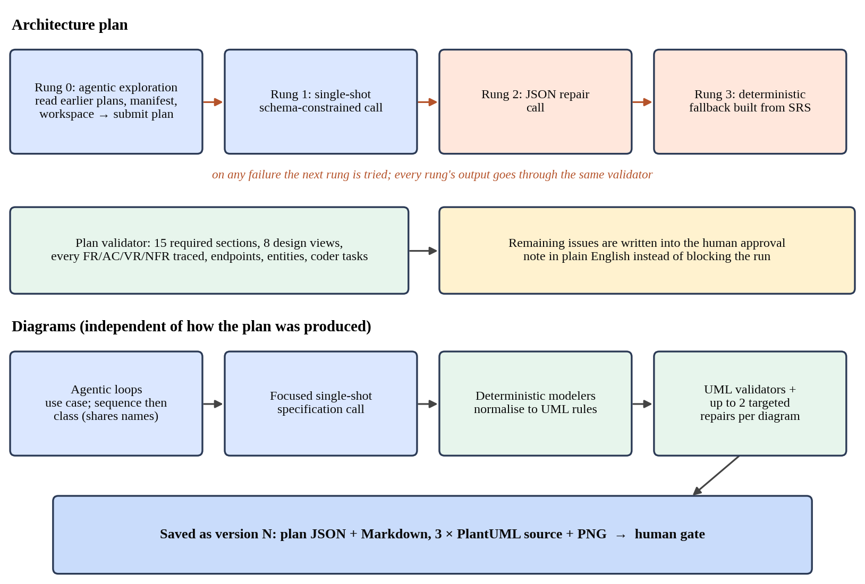
Figure 4.2: Architecture plan generation ladder and diagram pipeline
Every rung's output passes through the same validator. It checks that all fifteen sections and all eight design views are present; that every functional requirement, acceptance criterion, validation rule and non-functional requirement identifier in the SRS appears in the traceability matrix; that every API expectation in the SRS has an endpoint in the interface view; that data requirements have data entities; that non-functional requirements are addressed in the quality view; and that every functional requirement is covered by at least one Coder Agent task. A transport failure, such as a timeout with an empty error message, is treated like an unusable response, so it moves the run to the next rung instead of crashing it.
If even the fallback plan fails a heuristic check, the run is not stopped. The plan has to exist before the UI/UX and Coder stages can run, so the agent writes the remaining issues into the plan's human approval note as short plain-English lines and lets a person decide. The same happens for diagram issues that survive repair.

4.4.3 UML diagram generation
Diagrams are generated separately from the plan, so their quality does not depend on which rung produced it. The model is never asked to write PlantUML. Instead it writes a small JSON specification: actors, use cases and relationships for the use case diagram; participants and ordered interactions for the sequence diagram; classes, attributes, operations and relationships for the class diagram. Each specification has three ways to be produced: an agentic loop of up to 20 steps with read and validate tools, a focused single-shot call, or, if both give nothing, the modeler's own deterministic default. The sequence specification is produced first, and the class step is given the finalised sequence names, which is what keeps the names in the two diagrams consistent.
Deterministic modelers then turn each specification into the final diagram model, applying feature-independent UML rules: actors are external roles or systems; the main use case represents the feature's goal; mandatory supporting behaviour becomes an include relationship and optional or error behaviour an extend relationship; sequence diagrams show the main success flow first and alternatives in alt fragments; and constraints, risks and non-functional requirements never become use cases, messages or classes.
Three validators check the result. Table 4.5 lists the main rules. When a diagram fails, the agent makes a small, targeted repair call that passes the validator's message back to the model and asks it to fix only the flagged issues, at most twice per diagram, rather than regenerating the whole plan. The final models are converted to PlantUML and rendered to PNG.
Table 4.5: Main UML rules checked by the diagram validators
Diagram | Rules
Use case | System boundary, at least one actor, use case and relationship; no technical components as actors; no generic, over-long or sentence-fragment names; no one action split into parallel steps; no name merging two distinct capabilities; correct include and extend direction; traceability to SRS identifiers; nothing from the SRS's out-of-scope list
Sequence | Participants and at least three messages; an actor and a boundary or control lifeline; messages only between existing participants; balanced alt and else fragments; no non-functional or architecture terms as messages; no out-of-scope behaviour
Class | At least one class; no duplicate classes; no requirements, risks or use case phrases as classes; attributes and operations as lists; relationships only between existing classes with valid types

4.4.4 Revision
A reviewer's revision request is turned into a short list of operations (add, remove, modify or set) aimed at a dotted path in the plan, for example design_views.context_view.external_systems. Python applies them. Because the plan's lists are keyed differently, a file by its path, an endpoint by its method and path, a task by its task identifier, the patcher looks at the shape of the list it finds at the path and matches items by identifier-like key first, then by exact text, then by a distinctive substring. Operations that cannot be matched are reported in the plan's revision record rather than dropped. After a revision the diagrams are regenerated through the focused single-shot route, since a person is waiting and the longer agentic loop would be a poor trade.

4.4.5 UI/UX page and component design
Figure 4.3 shows the UI/UX pipeline. The agent first loads the approved SRS (or Enhanced SRS), the approved architecture plan and the project's design system, and makes one model call to produce ui_metadata_json. This lists the pages, each with its route, actors, the requirement identifiers it covers, its interaction states and its components. Each component lists the specific content it displays, grounded in the data entity's real fields, and says whether it reuses a component from the design system or why a new one is needed. The model also chooses one colour family for the whole feature, so every component uses the same accent colour.
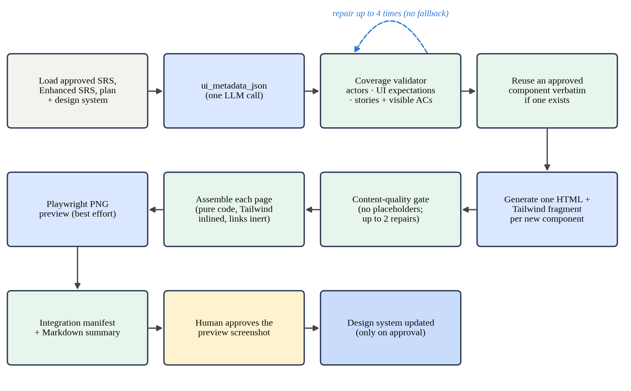
Figure 4.3: UI/UX Agent pipeline from metadata to approved design
A coverage validator then checks that every user role appears on at least one page, every UI expectation is covered by a component, and every user story and every acceptance criterion whose text implies a screen (words such as display, message, redirect, form or button) is listed by a page. It also rejects content lists that simply echo the prompt's own example text, a failure seen in a real run. If coverage fails, the validator's message is sent back for a targeted repair, up to four times. There is deliberately no deterministic fallback: a guessed screen design would mislead the reviewer more than an honest failure.
Components are then generated one at a time, each as a fragment of static HTML with Tailwind CSS classes and realistic example content. If a component of the same name has already been approved in another feature of the project, its approved markup is reused word for word instead of generating a new copy. The model returns the HTML after a plain text marker rather than inside JSON, because multi-line HTML inside a JSON string is a common cause of escaping errors. Each fragment passes a content-quality gate that rejects placeholder text such as "No data available", "Unknown state", "Coming soon", "lorem ipsum" or "TODO", with up to two targeted repairs. Because components are generated separately, one broken component can be repaired without touching the others.
Pages are assembled in plain code. Each page joins its component fragments into a complete HTML document with the Tailwind script embedded, so the file opens without a network connection, and with a small script that makes every link inert. That script fixes a real bug: a link with href="#" inside the preview frame used to load the host application inside its own preview. Playwright then takes a PNG screenshot of each page for the gallery, on a best-effort basis; the primary preview is the HTML itself. Finally, the agent builds an integration manifest for the Coder Agent, listing each page's route, navigation entry, components and content, and a Markdown summary for the reviewer.

4.4.6 Approval, cascades and the design system
Each stage produces several artefacts that belong together. For the architecture stage these are the plan JSON, its Markdown version and the six diagram files; for the UI/UX stage they are the metadata, manifest, Markdown, component and page files and the screenshots. A reviewer approves one artefact, the plan or a preview screenshot, and the approval service applies the same decision to the rest of that version. Approving a newer version returns the previously approved one, and its siblings, to pending. The cascade never touches other versions or unrelated artefact types, and each cascaded artefact records that its approval came from the cascade.
Approving a UI/UX design is also the only thing that updates the project's design system. New components and tokens from the approved version are merged into design_system.json, so a later feature can reuse them. A rejected or revised design leaves the design system untouched. UI/UX revision uses targeted operations on components, matched by page and component name, and when the reviewer selects specific pages, any operation that would touch another page is rejected and reported.

4.5 Standards and Professional Practice
The diagrams follow UML notation for use case, sequence and class diagrams, and the validators encode its common conventions. The plan's design views follow the long-standing practice of describing an architecture through several views for different concerns, and the traceability matrix links each design element to stable requirement identifiers, which is the forward link that traceability research [5], [6] treats as essential. Endpoints follow REST conventions, and file paths follow the conventions of the Next.js App Router.
On the engineering side, all inputs and outputs are typed schemas, validators and modelers contain no feature-specific rules, agentic tools follow least privilege by being read-only, and every artefact is versioned. Model output is treated as untrusted input that is parsed, validated and, where necessary, rejected or flagged before anything downstream relies on it.

5 IMPLEMENTATION

5.1 Development Environment and Technology Stack
Both agents are Python packages inside the team's FastAPI backend. Table 5.1 lists the main technologies and the reason for each.
Table 5.1: Technology stack used by the component
Concern | Technology | Why it was used
Web API and schemas | FastAPI, Pydantic | Typed requests and responses; streaming progress to the interface
Agentic loops | LangChain create_agent with LangGraph | Tool-using loops with a step limit for plan and diagram exploration
Default LLM | qwen3-coder via Ollama | Local model that followed the JSON schemas reliably
Diagram rendering | PlantUML (Java) with Graphviz | Text-based UML that renders consistently and can be versioned
Page styling | Tailwind CSS (embedded script) | Utility classes an LLM writes well; no build step for previews
Preview screenshots | Playwright, headless Chromium | Reliable screenshots of already-painted HTML
Artefacts | MongoDB records + versioned files | Shared artefact store and approval records of the team
Frontend | React 19, Vite, Tailwind CSS 4, TanStack Query | The team's shared interface stack
Testing | pytest | Fixture-based tests of deterministic logic and stubbed model calls

5.2 Implementation of the Core Modules
Each agent follows the team's package layout: an entry point, a prompt module, a schema module and stage-specific modules. Table 5.2 lists the main modules and their size. The Architecture Agent package has about 13,000 lines and the UI/UX Agent package about 3,300, which reflects where the difficulty lay: getting reliable diagrams took far more code than getting reliable pages.
Table 5.2: Main modules of the component
Module | Lines | Responsibility
architecture_agent/agent.py | 4,280 | Run and revise flows, ladder, diagram tiers, fallback plan, implementation plan
architecture_agent/prompt.py | 1,642 | Plan, diagram, repair and revision prompts
architecture_agent/usecase_modeler.py + validator | 1,889 | Use case normalisation and UML rule checks
architecture_agent/sequence_modeler.py + validator | 1,114 | Sequence model and fragment checks
architecture_agent/class_modeler.py + validator | 1,089 | Class model and structural checks
architecture_agent/sds_validator.py | 335 | Plan structure and SRS coverage
architecture_agent/revision_patcher.py | 316 | Targeted plan operations
architecture_agent/tools.py, diagram_tools.py | 525 | Read-only planning tools and diagram tools
uiux_agent/agent.py | 1,458 | Run and revise flows, component reuse, artefacts, design system patch
uiux_agent/prompt.py | 439 | Metadata, component, repair and revision prompts
uiux_agent/metadata_validator.py | 222 | Coverage and placeholder checks
uiux_agent/component_generator.py | 203 | Per-component HTML generation and content gate
uiux_agent/revision_patcher.py | 292 | Targeted component operations with page scoping
uiux_agent/page_html_builder.py, preview_renderer.py | 213 | Page assembly and screenshots

5.2.1 Architecture Agent
The agent's run function checks that an approved SRS exists, loads the approved Enhanced SRS if requested and available, loads every other feature's latest approved plan and the project manifest, and then calls the generation ladder. The ladder shares one small state dictionary across its rungs, so an expensive agentic diagram attempt is made at most once per run and, if it succeeded on one rung, is reused on the next instead of being thrown away.
The planning tools for the first rung are built separately from the Coder Agent's tools on purpose. The Coder Agent's tool builder creates the project's workspace as a side effect, which would be wrong for a stage that runs before any code exists. Workspace paths are resolved inside the project's workspace, and a path that tries to escape it is refused. The submit tool does not return the plan as text; it writes the JSON argument into a captured dictionary, which the agent reads after the loop, so there is no free-text chat output to parse.
The fallback plan is built from the SRS section by section: endpoints from API expectations, data entities from data requirements, behaviour from functional requirements and acceptance criteria, error handling from validation rules, the quality view from non-functional requirements, and a traceability row for every identifier. Two parsers turn SRS text into structure. One reads an API expectation such as "POST /api/items" into a method and a path; before it existed, every endpoint defaulted to GET and four CRUD endpoints collapsed into four identical GETs. The other reads a data requirement written as "price (number, required)" into a field name, type and required flag, and consolidates all data requirements into one entity instead of one entity per field. When a data requirement does not match that shape, the fallback infers field names from its words. Chapter 6 shows what this does to a requirement written in a different format.

5.2.2 Diagram pipeline
The three modelers and three validators are independent classes, each with no knowledge of any particular feature. The use case validator is the largest, because use case naming produced the most varied failures. Two of its checks pull in opposite directions. One catches a single action split into several parallel steps under the same use case, for example "Validate Email", "Validate Password" and "Validate Credentials" for one login. The other catches a single name that merges two goals, such as "Add List Items" for a feature that both adds and lists items. A third check catches names cut from the middle of a sentence, such as "A Task The Can", by looking for names made mostly of articles and pronouns.
The PlantUML builders emit plain source files, and a small renderer runs PlantUML, first as an installed command and otherwise from the jar file named in the configuration, to produce each PNG.

5.2.3 UI/UX Agent
The UI/UX Agent's run function checks for an approved SRS and an approved architecture plan, loads the design system and calls, in order, metadata generation with coverage repair, component generation, page assembly and rendering, the integration manifest builder and the Markdown builder. Preview rendering uses Playwright's synchronous API, which cannot run inside the server's event loop, so it is called in a worker thread. A failed screenshot is logged and skipped rather than failing the run, since the HTML page is the primary preview.
Component reuse looks up an approved fragment of the same name in any feature of the same project and returns the latest approved version unchanged. This was added after a second-feature test in which the Signup feature correctly marked LoginForm as reused, but the agent generated a fresh LoginForm anyway, so the flag was only a label.

5.2.4 Interface support
On the frontend, the component has chat panels for both agents, a viewer for the architecture plan, a gallery of the rendered diagrams, a page-preview panel that shows each assembled page live in a sandboxed frame, and a list that groups UI/UX artefacts by version. Reviewers can also download all preview images of one version as a single zip file.

5.3 Integration with the Complete Solution
Integration with the requirement stage is through the approved SRS and Enhanced SRS. A helper prefers the Enhanced SRS whenever one has been approved, both in the single-shot prompt and in the agentic prompt, and tests check that the two prompts make the same choice.
Integration with the Coder Agent happens through three artefacts. The implementation plan gives the files, endpoints and models to build and the order to build them in; tests confirm that the Coder Agent's planner prompt includes it and leaves it out for old plans that do not have one. The page designs and the integration manifest give the routes, navigation entries and the content each page should show. The project manifest, which the Coder Agent updates after each merged feature, flows back into the next feature's architecture plan.
Integration also exposed mismatches between conventions. The Requirement Agent's own prompt shows data requirements in the form "name (string, required)", and the fallback plan's parser was written for that form. In practice, analysts also answered in the form "name: string", and from 20 August the requirement quality gate accepted that form as a structured field, so such entries reached the SRS unchanged. The Architecture Agent's parser did not recognise them. Section 6.2.1 shows the consequence. Mismatches like this are easy to miss, because each agent's own tests pass.

5.4 Testing and Quality Assurance
Table 5.3 summarises the automated tests for the component. Appendix A lists every test file.
Table 5.3: Automated tests for the component
Area | Test files | Test functions
Architecture plan, ladder, tools and revision | 11 | 91
UML modelers, validators, builders, tools and repair | 18 | 165
Architecture approval cascade | 1 | 6
UI/UX metadata, components, pages, reuse and revision | 10 | 92
UI/UX approval cascade | 1 | 7
Total | 41 | 361

Several tests target the fallback paths directly, because those paths only run when something has gone wrong and are otherwise rarely exercised. They check that a plan submitted through the exploration tools is used without any further model call; that a loop which never submits, or hits its step limit, falls back cleanly; that a timed-out call moves to the repair rung and then to the fallback; and that the streaming version of the run ends with a final event rather than an error. On the UI/UX side, tests check that a component failing the content gate once is repaired, that one failing every attempt raises a clear error, and that approving a design updates the design system while rejecting it does not.
The last recorded run of the backend suite, on 31 August 2026, collected 382 test cases whose names refer to the architecture or UI/UX stages, counting parameterised cases. The failures recorded for this component in that run's cache all belong to tests that have since been renamed or removed, so no current test of the component is recorded as failing. Like the rest of the backend suite, some tests need a running MongoDB database through the shared test setup.
Tests cannot show whether a generated design is good, only whether the rules hold. The quality of the designs was checked by reviewing the stored artefacts at each milestone, which is how the problems reported in Chapter 6 were found.

5.5 Deployment and Operation
The component is deployed with the AutoForge backend. In addition to the team's requirements, it needs Java with the PlantUML jar and Graphviz for diagram rendering, and Playwright with Chromium for screenshots. The Tailwind script is stored inside the repository and embedded into each page, so previews need no internet access. Each project's design system and manifest are stored as JSON files beside its artefacts, and both persist across restarts.

6 RESULTS AND EVALUATION
This chapter reports the results in the order of the research questions, after summarising what the automated tests established. Pipeline-level results come from the team's evaluation in our research paper. The rest come from the artefacts my agents stored for two features developed during the project: "Add & List Items" in a Retail Store project and "Item Listing" in a project called Finodil. These artefacts include weak outputs as well as good ones, and I report both.

6.1 Component-Level Test Results
Table 6.1 lists the behaviours that the rest of the pipeline relies on and the tests that check them. All were passing in the last recorded run. They show that the deterministic rules hold; they do not show that the designs are good, which is the subject of Section 6.2.
Table 6.1: Key behaviours confirmed by automated tests
Behaviour | Test file | Result
A plan submitted through the exploration tools is used with no further model call | architecture_agent_exploration | Pass
A loop that never submits, or hits its step limit, falls back cleanly | architecture_agent_exploration | Pass
A timed-out call moves to the repair rung and then to the fallback | architecture_agent_transport_errors | Pass
Several data requirements become one entity; CRUD endpoints keep their real methods | architecture_data_requirements_consolidation | Pass
Only other features' approved plans are given as project context | architecture_project_context | Pass
Revision operations change only their target; unmatched ones are reported | architecture_revision_patcher | Pass
Fragmented, conjoined and sentence-fragment use case names are rejected | architecture_usecase_validator_quality | Pass
Approving a plan approves its Markdown and six diagram files, and nothing else | approval_architecture_cascade | Pass
A placeholder component is repaired; one that keeps failing raises an error | uiux_agent_quality_gate | Pass
An approved component is reused word for word, from the same project only | uiux_component_reuse | Pass
Page-scoped revisions cannot touch other pages | uiux_revision_patcher | Pass
The design system changes on approval only | approval_uiux_cascade | Pass

6.2 Experimental Results

6.2.1 Traceability of architecture plans (RQ1)
The retail store plan, version 1, is a useful test of RQ1 because it was produced by the deterministic fallback rung. Its endpoint purposes all read "Support the Add & List Items feature." and its entity purpose reads "Core data entity for the Add & List Items feature.", which is the fallback's own template text. In other words, the model had failed on every earlier rung, and this is what the safety net produced. Table 6.2 shows its traceability matrix.
Table 6.2: Traceability matrix of the retail store plan, version 1
Traced item type | Rows | Required by the validator
Functional requirements (FR-001, FR-002, FR-DOM-001) | 3 | Yes
Acceptance criteria | 5 | Yes
Validation rules | 4 | Yes
Non-functional requirements | 3 | Yes
Data requirements, constraints, UI and API items, risks, dependencies | 21 | No (traced for completeness)
Total | 36

Every identifier the validator requires is traced, including FR-DOM-001, the detail-view requirement that the Domain Agent added, which shows that the Enhanced SRS was used. All six Coder Agent tasks name their related requirements, and the implementation plan lists a Route Handler at app/api/items/route.ts, a model file, a page and an ordered list of five build steps. By the validator's measure, the plan is complete.
The data entity tells a different story. The SRS wrote its data requirements in the form "name: type", which the fallback's field parser does not recognise, so it fell back to inferring field names from the words of each requirement. Table 6.3 shows the result.
Table 6.3: SRS data requirements and the fields the fallback produced
SRS data requirement | Fields produced (all String, none required)
image: file upload (stored and served back as an image URL) | image, fileUpload, storedAndServedBackAsAnIm, ageURL
name: string | name, string
description: text (optional) | description, text, optional
price: number | price, number
quantity: number | quantity, number
createdAt: date (set automatically when the item is created) | createdAt, date, setAutomaticallyWhenTheItem, isCreated

Six real fields became seventeen, with fields called string, number and optional, a field name cut in half (storedAndServedBackAsAnIm and ageURL), price and quantity typed as text, and no field marked as required. The same entity appears in the implementation plan's model and in the class diagram (Figure 6.2). Nothing in the validator objected, because it checks that a data entity exists, not what is in it. The Finodil Item Listing plan shows the same pattern on a smaller scale, with extra fields named itemsTable and string.
The answer to RQ1 is therefore split. Deterministic coverage validation did keep the plan traceable: no SRS identifier went missing, even on the fallback path. But traceability shows that each requirement was planned for, not that it was planned well. A reviewer approving this plan on the strength of its traceability matrix would pass a broken data model to the Coder Agent.

6.2.2 Quality of the generated UML diagrams (RQ2)
The tests show that the validators catch each rule violation they were written for. The stored diagrams show which errors reach the reviewer anyway. Table 6.4 summarises what I found in the PlantUML sources of the two development features, and whether a validator flagged it.
Table 6.4: Issues in stored diagrams and whether they were flagged
Diagram | Issue | Flagged
Retail use case v1 | One use case, "Add List Items", merging two goals | Yes, in the approval note
Retail use case v1 | External actor "Image Hosting Solution To", cut from the dependency sentence | No
Retail sequence v1 | Unrelated SecurityTokenProvider asked to "Generate required output credential/token" | No
Retail sequence v1 | Listing items placed in an "Optional or alternative user flow" fragment | No
Retail class v1 | Request and response DTOs with a single attribute "field: String"; seventeen-field entity | No
Finodil use case v1 | External actor "No External Dependencies Were", cut from a plan note | Revised by reviewer
Finodil use case v2 | Duplicate actors "Logged In User" and "Logged In Users", one unconnected | No
Finodil use case v2 | Interface states and domain notes as use cases ("Show Loading Indicator", "Use Stock Movement Logs") | No
Finodil use case v2 | Use case diagram missing traceability for AC-003 | Yes, in the approval note

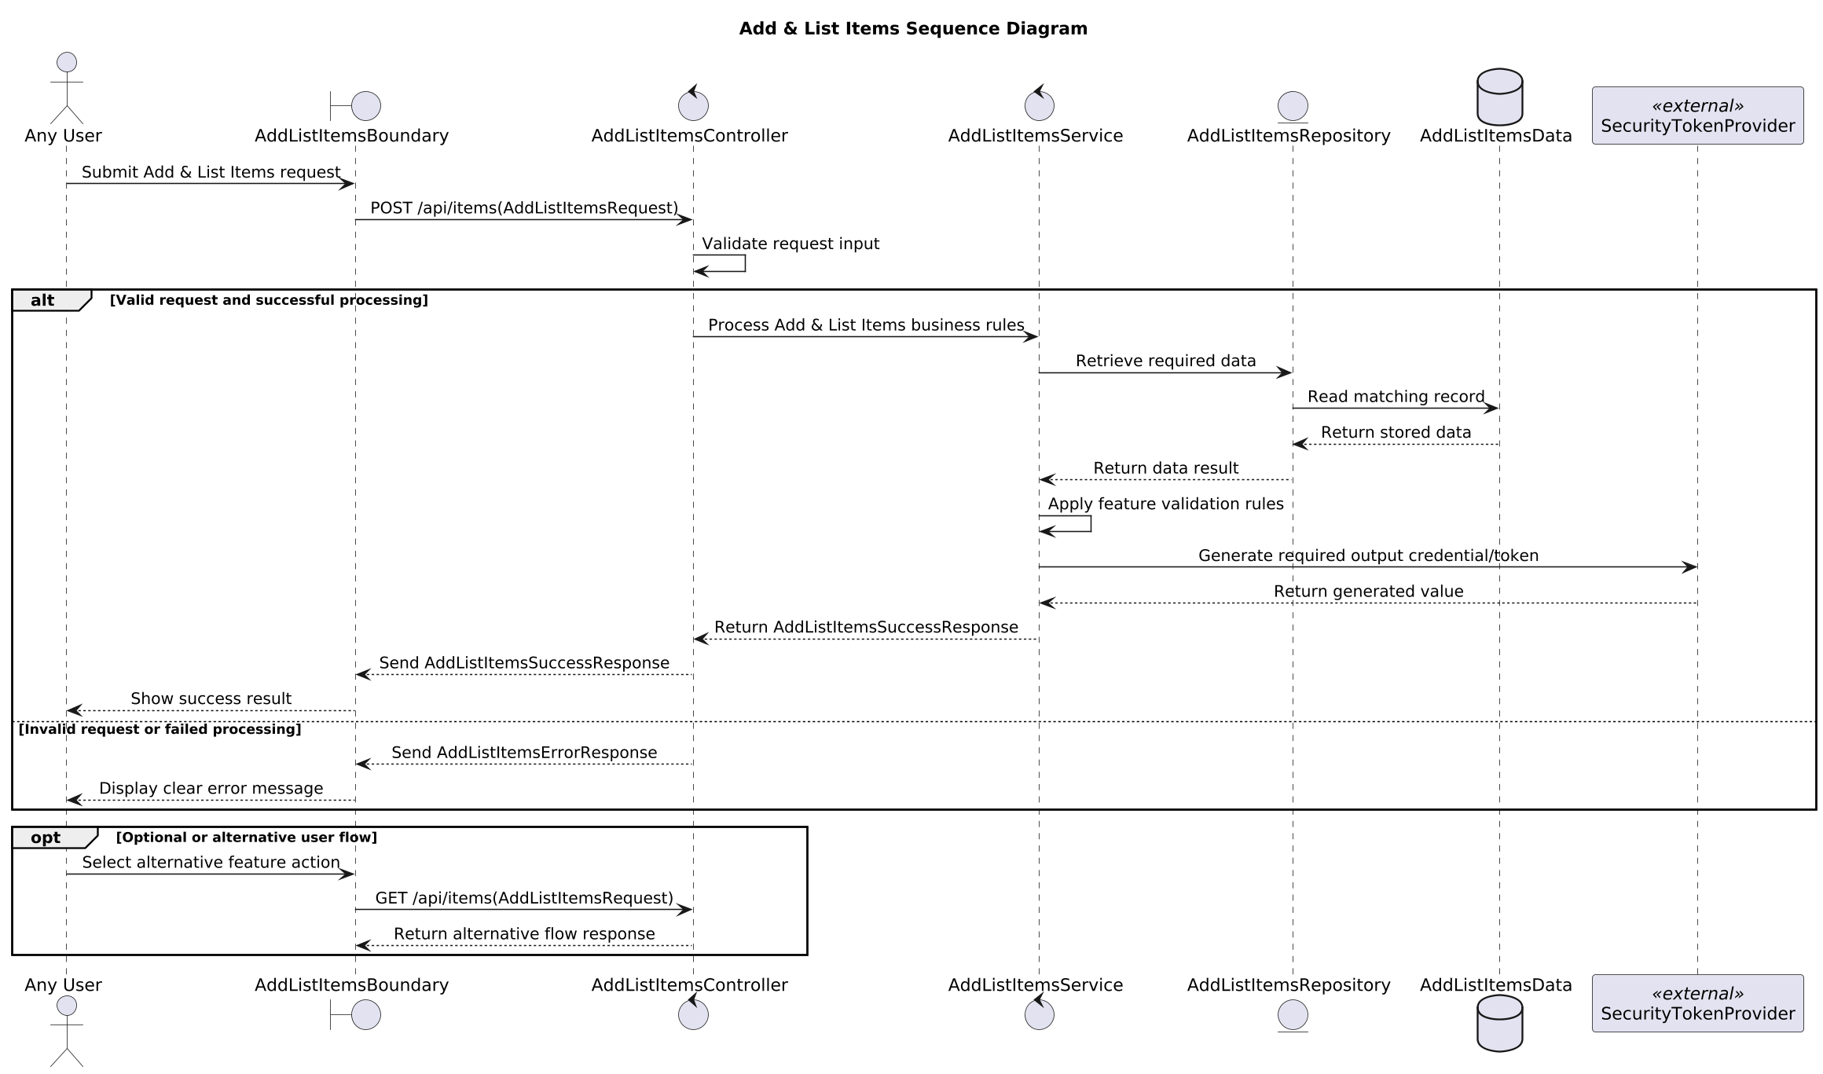
Figure 6.1: Retail store sequence diagram, version 1, rendered from the agent's PlantUML source
Figure 6.1 shows the retail store sequence diagram. Structurally it follows the rules: an actor, a boundary, controllers, a repository and a data store, ordered messages, and balanced alt, else and opt fragments. In content it is generic. Its messages could belong to any feature, it reads a "matching record" while adding an item, and it calls a security token provider that has nothing to do with this feature. The class diagram in Figure 6.2 has a sensible layered shape, with a controller, a service, a repository, an entity and data transfer objects, but the objects themselves carry placeholder attributes and the entity carries the fields from Table 6.3.
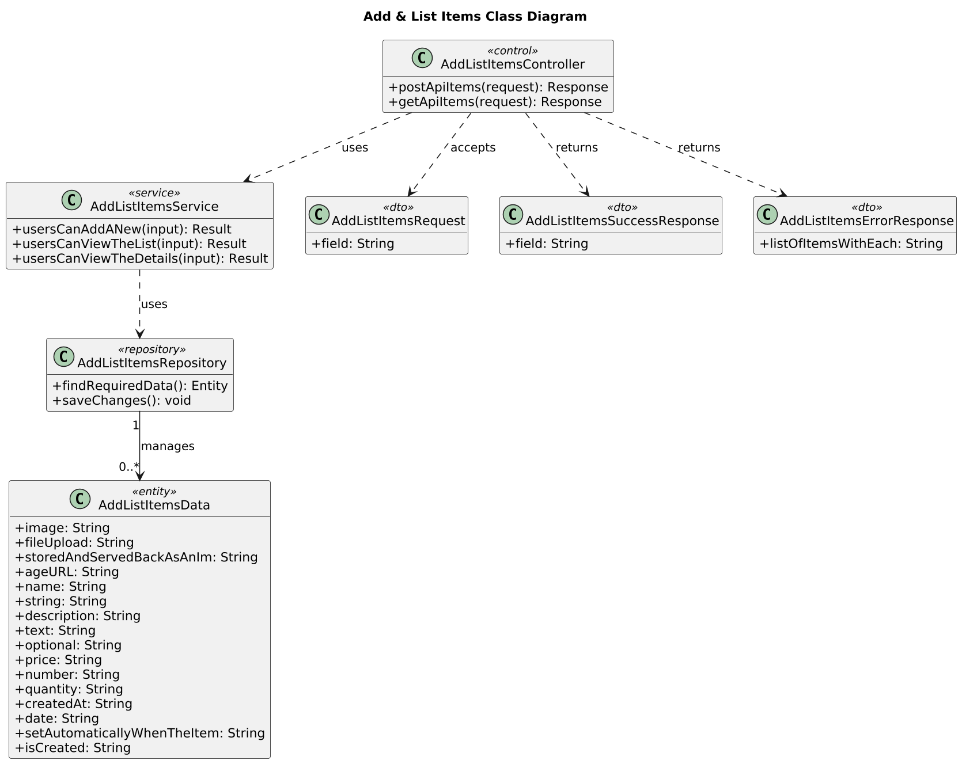
Figure 6.2: Retail store class diagram, version 1, rendered from the agent's PlantUML source
The Finodil use case diagram shows what a revision can and cannot fix (Figure 6.3). The reviewer asked to "enhance the use case diagram more and remove the <<external system>> actor". The revision record shows that the agent removed the note from which the false actor had been made, and version 2 no longer has it. But the regenerated diagram brought new problems: a second, unconnected actor with a plural name, interface states such as "Display Empty State" as use cases, and four included use cases that are implementation or domain notes rather than user goals, such as "Use Stock Movement Logs". The only issue the validators reported for version 2 was a missing trace to AC-003.
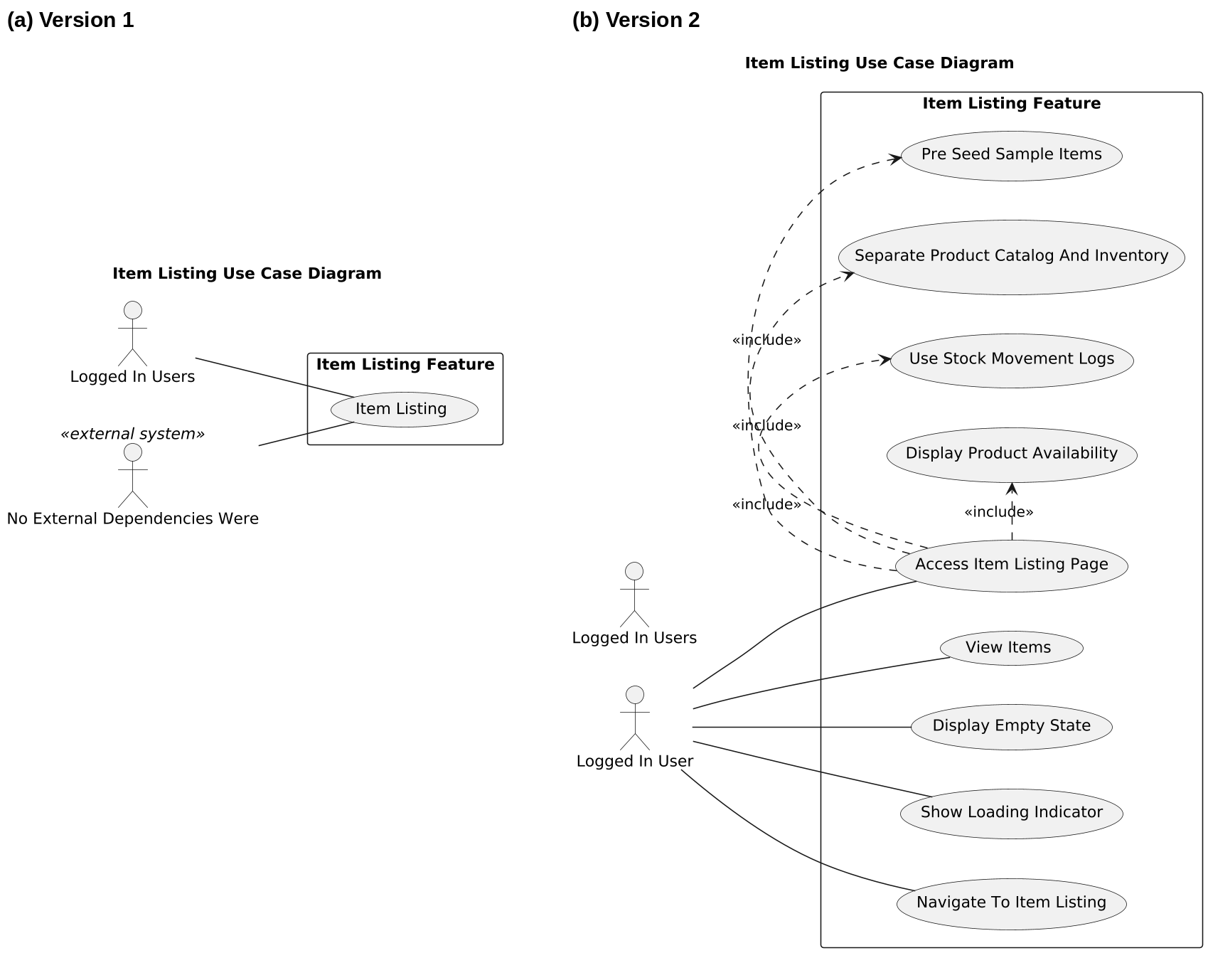
Figure 6.3: Finodil Item Listing use case diagram before and after revision
For RQ2, the result is that the modelers and validators reliably prevent the errors they encode, and the approval note makes the remaining flagged ones visible. They do not prevent errors of meaning. Names cut from sentences, generic messages and irrelevant participants pass, because they break no structural rule. The worst cases came from the fallback paths, where the model's contribution was smallest.

6.2.3 Completeness of the page designs (RQ3)
The UI/UX output for the retail store feature was considerably stronger. The metadata defines two pages, Add Item at /add-item and List Items at /list-items, each with one new component, AddItemForm and ItemListGrid, and an indigo colour theme. Between them the pages cover FR-001 and FR-002, both user stories and all five acceptance criteria. Figure 6.4 shows the two previews.
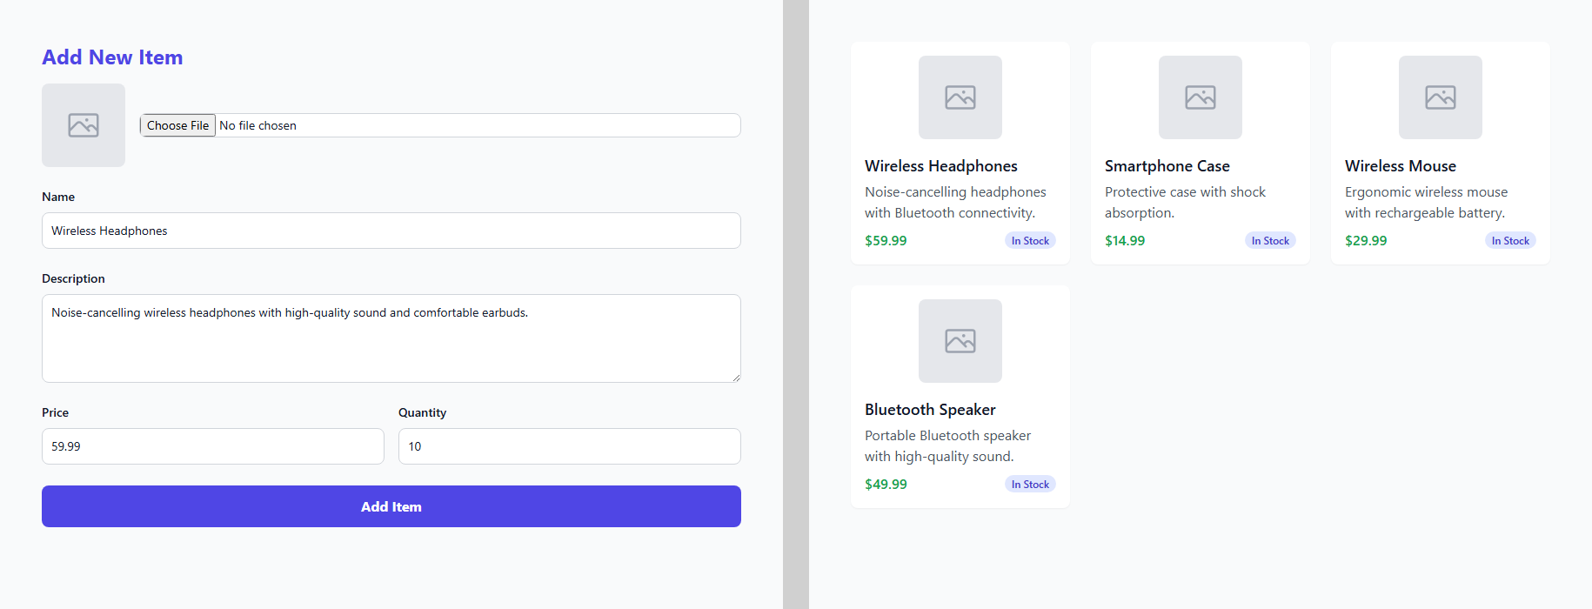
Figure 6.4: Retail store page previews, version 1: Add Item (left) and List Items (right)
Both pages show realistic, fully populated content: a form with the five fields from the SRS and example values, and a grid of four item cards with names, descriptions and prices. Neither contains placeholder text. Both components were later recorded in the project's design system as introduced by this feature, which only happens when the design is approved.
A closer comparison with the SRS and the architecture plan found four gaps, listed in Table 6.5.
Table 6.5: Gaps found in the retail store page design
Gap | Why the checks did not catch it
No page for FR-DOM-001, viewing an item's details | The validator requires user stories and screen-related acceptance criteria, not functional requirements
The UI expectation "Responsive on both desktop and mobile widths" is not covered by any component | The SRS stores UI expectations as plain strings, but the validator only reads items with an "element" field, so the check never ran
Routes /add-item and /list-items differ from the plan's single /add-list-items page | No check compares the UI/UX metadata with the architecture plan's frontend pages
Item cards show an "In Stock" badge that no requirement asks for | Invented content passes the placeholder check by design

The second gap is the most instructive. The coverage check was written and tested against UI expectations stored as objects, but the Requirement Agent's normalisation turns them into plain strings, so on real data the check silently did nothing. For RQ3, then: per-component generation, the placeholder gate and deterministic assembly produced complete, realistic and reviewable pages, which is a clear improvement on the earlier React version that could show "Unknown state.". Coverage, however, was only as good as the rules, and one rule was not running.

6.2.4 Human review at the design stages (RQ4)
In the team's Item Listing case study, both of my stages needed revision before approval. The architecture plan and its diagrams were approved at version 3, after the reviewer corrected an actor in the diagrams. The UI/UX design was also approved at version 3, after component-level fixes. Across the whole pipeline, four of the seven stages of Item Listing were revised, and two of those four were mine. Table 6.6 shows the team's comparison of the full pipeline with human gates on and off.
Table 6.6: Pipeline with human gates on and off
Measure | Gates ON | Gates OFF
Successful pipelines | 3/3 | 2/3
Average revisions | 5.0 | 1.0
QA pass rate | 91% | 78%
Security issues | 1 | 4
Escaped defects | 1 | 5
Human review effort | 36 min | 0

The development artefacts add detail to this. In the Finodil feature, the reviewer caught and removed a false actor that no validator had flagged. In the retail store feature, the approval note told the reviewer about the merged use case. Problems such as the broken data entity and the uncovered responsive expectation are exactly the kind a reviewer can see in seconds and a rule cannot. For RQ4, the evidence is that review at the design stages did catch real problems before code, and that it is needed most where the deterministic checks are weakest.

6.3 Stakeholder and User Validation
No external users or industry stakeholders evaluated the component. All reviews were done within the project team, whose members know the system and the expected output. A software architect or UI designer outside the team would probably judge the diagrams and pages more strictly, and that remains to be tested.
Feedback within the team did shape the design in at least two recorded cases. Human approval of the UI/UX stage was restored at the team's request after a period in which the stage was not gated, as the approval service's own notes record. And page-scoped revision, which at first was only a hint in the prompt, was made a hard rule after a revision meant for one page could also change others.
[Student to complete: add any feedback from the supervisor, co-supervisor or panel on the architecture plans, diagrams or page designs, with dates.]

6.4 Integration and Performance Results
My stages ran in every pipeline run of the team's evaluation, and all three features completed all seven stages with gates on. Table 6.7 shows the cost of each run. The logs do not separate the time spent in each stage, so I do not claim a figure for my stages alone.
Table 6.7: Execution performance of the full pipeline
Run | Total time (min) | LLM calls | Retries | Tokens
Item Listing | 36.4 | 24 | 4 | 31,800
Authentication | 52.7 | 31 | 6 | 42,600
Shopping Cart | 56.8 | 34 | 7 | 47,900
Baseline | 31.2 | 18 | 3 | 25,400

Two integration results concern my component directly. First, the Coder Agent consumed the implementation plan as intended: its planner prompt includes the plan's files, endpoints and models, as the integration tests confirm. Second, the integration problems found in Section 6.2 sit at the boundaries between agents: the data-requirement format between the Requirement and Architecture agents, the shape of UI expectations between the Requirement and UI/UX agents, and the page routes between the Architecture and UI/UX agents. None of them would have been found by testing one agent alone.

6.5 Summary of Findings
Table 6.8: Summary of findings by research question
RQ | Finding | Strength of evidence
RQ1 | Every required SRS identifier was traced, even on the fallback path, but a traced plan held a broken data entity | Validator tests; two stored plans
RQ2 | Modelers and validators prevent rule violations and surface some issues; errors of meaning, mostly from fallback paths, still pass | Tests; nine issues in five stored diagrams
RQ3 | Pages were complete, realistic and free of placeholders; one requirement and one expectation had no page, and routes disagreed with the plan | Tests; one feature's stored designs
RQ4 | Reviewers revised both design stages in the case study and caught issues no validator flagged | One case study; development revision records

7 DISCUSSION

7.1 Interpretation of the Results
The results support the idea behind the component, letting the model propose and letting code and a person decide, but they also show its limit more clearly than I expected. Deterministic checks are good at the question "is it all there?" and poor at the question "is it right?".
On the first question the component did well. No SRS identifier went missing from a plan, even when the model failed on every rung and the fallback took over. Every page design covered its user stories and screen-related acceptance criteria, and no preview showed placeholder content. These were real problems in early versions, and the deterministic steps removed them.
On the second question the results were mixed. The data entity in Table 6.3 is the clearest example. It satisfied every rule, yet a developer would reject it at a glance. The same is true of the generic sequence messages and the cut-off actor names. None of these break a structural rule, so a rule-based validator cannot see them. This is not an argument against validation; without it the plans and diagrams would be worse. It is an argument against reading a passing validator as approval.
A second pattern is that the weakest outputs came from the fallback paths. The fallback did its job, which was to give the reviewer something to look at instead of a failed stage, but its output is only as good as the parsers that turn SRS text into structure. When the SRS used a format the parser did not expect, the result was nonsense presented in a confident structure. The fallback therefore needs to say more loudly that it was used. At present the failure reason reaches the fallback builder but is not written into the plan, so only the template wording reveals what happened.
The UI/UX results were better than the architecture results, and I think the reason is the different attitude to failure. The UI/UX Agent has no fallback, generates small pieces one at a time, and assembles them in code. Each piece is small enough for the model to do well and for a simple check to judge. The Architecture Agent's diagrams, by contrast, depend on the whole plan, and their deterministic defaults are generic by necessity.

7.2 Comparison with Related Work
Like MetaGPT [2], my component turns a requirement document into a structured design and diagrams before any code is written. The differences are in checking and control. MetaGPT's design is reviewed by other agents; here, every design is checked against the SRS by code and then approved or revised by a person at a durable checkpoint, and the diagrams are checked against UML rules. My results suggest both matter. Code caught missing coverage that a person might overlook, and a person caught meaning errors that code could not see.
Compared with ChatDev [1], where design is part of an agent conversation, my component produces design artefacts that can be reviewed, versioned and approved separately. HULA [7] found that engineers value reviewing an agent's plan before coding. My case-study results are consistent with that: both design stages were revised before approval. Coding agents such as SWE-agent [3] and OpenHands [4] assume the design already exists; the implementation plan is my component's attempt to give a coding agent exactly that, in a form it can follow file by file.
On traceability, the plan's matrix provides the requirement-to-design link that Gotel and Finkelstein [5] describe, and it is checked on every plan. The results add a caution that the traceability literature [6] also implies: a link records that a relationship was claimed, not that it is correct.

7.3 Implications for Practice
Three lessons may be useful to anyone building a similar stage. First, test deterministic checks against the real output of the previous agent, not only against hand-written fixtures. Two of the most important problems I found, the data-requirement format and the plain-string UI expectations, passed every unit test because the fixtures used the shape the code expected. Second, make a fallback announce itself. A safety net that produces plausible-looking output can do more harm than an honest failure if the reviewer does not know it was used. Third, give the reviewer the right view: diagrams and live page previews are much faster to judge than JSON, and most of the meaning errors in Chapter 6 are obvious once seen.

7.4 Threats to Validity
Internal validity. The artefact analysis was done by a member of the team that built the agents. I tried to reduce bias by tying every finding to a stored file and reporting weak outputs, but another reviewer might judge some diagrams differently.
External validity. The detailed analysis covers two development features, and the case study three features, all in e-commerce and all targeting one stack. Plans for larger features, or for a different stack, may behave differently. Most results come from one default model; a stronger model would probably reach the fallback paths less often.
Construct validity. Counting traced identifiers measures coverage, not design quality, which is precisely the point made in Section 6.2.1. Diagram quality was judged by inspection against UML conventions rather than with a formal metric.

7.5 Limitations
• The plan validator checks that a data entity exists, not that its fields are sensible, and the fallback's field parser recognises only the "name (details)" form.
• The fallback plan does not record that the model failed. The failure reason is passed to the fallback builder but never written into the plan, so only the template wording gives it away.
• The UI/UX coverage check for UI expectations reads only object-shaped items, so it does not run on the plain-string expectations the Requirement Agent actually produces.
• The UI/UX validator does not require every functional requirement to have a page, and does not compare its routes with the architecture plan.
• The diagram validators cannot detect meaning errors such as names cut from sentences, duplicate actors with plural names, or irrelevant participants.
• No architect or designer outside the team reviewed the outputs.

8 COMMERCIALISATION AND SUSTAINABILITY

8.1 Value of the Component
The common report sets out the case for AutoForge as a whole: teams using AI to build software need to see and approve each stage before it ships. My component contributes the stage where most of the visible design work happens, and two of its outputs would be useful on their own.
The first is a design pack for a feature: an architecture plan organised into views, a traceability matrix, three UML diagrams and a file-level implementation plan. Small agencies often skip written design for small features because it takes time. A first draft that a developer can correct in minutes changes that trade-off. The second is clickable-looking page previews with realistic content, which a client can approve before any code is written. In agency work, a client who sees the screen early is less likely to ask for changes after it has been built.

8.2 Target Users and Market Position
The direct users are developers, technical leads and designers in small e-commerce teams and agencies, and indirectly their clients, who approve the screens. Table 8.1 compares the component with what these users can do today.
Table 8.1: Alternatives for producing a feature design
Alternative | Strength | Weakness compared with this component
Designing by hand | Full judgement and context | Slow; often skipped for small features; traceability rarely kept
General chat assistant | Fast and flexible | No fixed structure, coverage check or UML rules; output not tied to requirement IDs
Prompt-to-UI tools | Attractive screens quickly | Not tied to a specification or architecture; no coverage check
Role-based frameworks such as MetaGPT [2] | Design documents within a pipeline | Reviewed by agents, not by a person at a durable gate
This component | Traced plan, UML diagrams, page previews, human approval, shared design system | Slower than a single prompt; outputs still need expert review

8.3 Business Model and Feasibility
The component fits the open-core model proposed in the common report. Two parts of a paid team edition would come directly from it. One is design-system management: the shared design system already persists components and tokens across features, and a team edition could let an agency keep one design system per client and reuse it on every new feature. The other is review features: approval cascades, page-scoped revision and version history are already in place and could be extended with comments and roles for client sign-off.
Technically the component is feasible on a single machine with a local model, as the evaluation shows. The results in Chapter 6 also point to the work needed before a commercial release: the fallback must announce itself, the data-model checks must look at field content, and the coverage checks must be tested against real upstream output. These are modest changes, but a product sold on trust cannot ship with a check that silently does not run.

8.4 Sustainability and Maintenance
Several design choices help the component stay maintainable. PlantUML and Tailwind are text formats that change slowly and can be stored in version control. The validators and modelers contain no feature-specific rules, so new features do not require new code. The implementation plan is tied to the Coder Agent's file conventions, so if the generated stack changes, the plan builder and its tests must change with it; keeping both in one place makes that change visible.
The main maintenance risks are the dependencies on PlantUML with Java and Graphviz, and on Playwright with Chromium, which add installation steps, and the growing size of the Architecture Agent's main module. Splitting the fallback plan builder and the diagram tiers into their own modules would make the agent easier to change.
Socially, the component keeps designers and developers in charge. It produces a first draft and a set of checks; a person decides. The risk discussed in Chapter 7 applies here too: a design that passes every check can still be wrong, so the product should present checks as help for the reviewer, not as a guarantee.

8.5 Contribution to the Sustainable Development Goals
The common report links AutoForge to SDG 9 (Industry, Innovation and Infrastructure) and SDG 8 (Decent Work and Economic Growth). My component's contribution to SDG 9 is a way to bring architecture and interface design, which small teams often skip, into their everyday process at low cost, using a model that can run locally. Its contribution to SDG 8 would come through small agencies, which could show clients screens and designs earlier and spend less time on rework.
These contributions are potential rather than demonstrated. A responsible next step would be a pilot with a small agency, measuring how often their developers accept, correct or reject the generated plans, diagrams and pages, and how much review time the stage saves or costs.

9 CONCLUSION AND FUTURE DIRECTIONS

9.1 Conclusion
This thesis set out to make the design stages of an LLM-based development pipeline produce designs that are traceable to the approved specification, follow modelling and interface conventions, and are reviewed by a person before code is written. The Architecture Agent produces a structured plan through a four-rung ladder, checks its coverage of the SRS, and generates UML diagrams through narrow specifications, deterministic modelers and rule validators. The UI/UX Agent plans pages and components, checks their coverage, generates each component behind a placeholder check, and assembles self-contained previews, with the shared design system updated only on approval.
The evaluation showed that the deterministic steps reliably guarantee completeness: no requirement went untraced, and no preview showed placeholder content. It also showed that completeness is not correctness. A fully traced plan carried a broken data entity, diagrams passed every rule while containing names cut from sentences and irrelevant participants, and a coverage check never ran because two agents disagreed on the shape of the data. In the case study, reviewers revised both design stages before approving them. The main lesson of this work is that deterministic checks and human review do different jobs, and a design stage needs both.

9.2 Achievement of Objectives
Table 9.1: Achievement of the objectives
Objective | Outcome | Status
O1: Architecture plan with implementation plan and SRS coverage check | Fifteen-section plan, eight views, implementation plan, four-rung ladder, coverage validator; data-model content not checked | Achieved
O2: UML diagrams through specifications, modelers and validators | Three diagram types with modelers, validators, targeted repair and PlantUML rendering; meaning errors still pass | Largely achieved
O3: UI/UX pages with coverage, realistic components, previews and shared design system | Implemented with coverage repair, content gate, reuse, page assembly, previews and approval-gated design system; one coverage check not running on real data | Largely achieved
O4: Evaluation including where checks fall short | 361 automated tests, case-study records and analysis of stored artefacts from two features | Achieved at limited scale

9.3 Contribution
The main contribution is a tested design for the architecture and UI/UX stages of a human-gated agent pipeline: a traceable architecture plan with a file-level implementation plan for a coding agent, a diagram pipeline that keeps the model away from the notation and checks the result against UML rules, and a page design pipeline that generates small pieces, rejects placeholders and assembles previews in code. The second contribution is evidence of where such checks stop working, drawn from real artefacts rather than test fixtures: format mismatches between agents, checks that silently do not run, and fallback output that looks complete. These failure modes are likely to appear in any multi-agent pipeline, and they are what a reviewer of such a system should look for.

9.4 Future Directions
The most direct improvements follow from Chapter 6. The fallback plan should state in its approval note that the model failed. The data-entity check should look at field names and types, for example rejecting fields named after types such as "string" or "number", and the field parser should accept the "name: type" form. The UI/UX coverage check should accept UI expectations as plain strings, require a page for every functional requirement with a visible effect, and compare its routes with the architecture plan's front-end pages.
Beyond these fixes, contract tests between agents would catch format mismatches early: each agent's checks should be run against the real stored output of the agent before it, not only against fixtures. Diagram quality could be improved by checking names against the vocabulary of the SRS, so that a name cut from a sentence or an actor not mentioned in the SRS is flagged. Finally, the evaluation should be repeated with more features, more than one model, and reviewers from outside the team, ideally an architect for the plans and a designer for the pages.

REFERENCES
[1] C. Qian, W. Liu, H. Liu, N. Chen, Y. Dang, J. Li, C. Yang, W. Chen, Y. Su, X. Cong, et al., “ChatDev: Communicative agents for software development,” in Proc. 62nd Annu. Meeting Assoc. Comput. Linguistics (Volume 1: Long Papers), 2024, pp. 15174–15186.
[2] S. Hong, M. Zhuge, J. Chen, X. Zheng, Y. Cheng, J. Wang, C. Zhang, S. Yau, Z. Lin, L. Zhou, et al., “MetaGPT: Meta programming for a multi-agent collaborative framework,” in Proc. Int. Conf. Learn. Representations (ICLR), 2024, pp. 23247–23275.
[3] J. Yang, C. E. Jimenez, A. Wettig, K. Lieret, S. Yao, K. Narasimhan, and O. Press, “SWE-agent: Agent-computer interfaces enable automated software engineering,” in Advances in Neural Information Processing Systems, vol. 37, 2024, pp. 50528–50652.
[4] X. Wang, B. Li, Y. Song, F. F. Xu, X. Tang, M. Zhuge, J. Pan, Y. Song, B. Li, J. Singh, et al., “OpenHands: An open platform for AI software developers as generalist agents,” in Proc. Int. Conf. Learn. Representations (ICLR), 2025, pp. 65882–65919.
[5] O. C. Z. Gotel and A. C. W. Finkelstein, “An analysis of the requirements traceability problem,” in Proc. IEEE Int. Conf. Requirements Engineering, 1994, pp. 94–101.
[6] J. Mucha, A. Kaufmann, and D. Riehle, “A systematic literature review of pre-requirements specification traceability,” Requirements Engineering, vol. 29, no. 2, pp. 119–141, 2024.
[7] W. Takerngsaksiri, J. Pasuksmit, P. Thongtanunam, C. Tantithamthavorn, R. Zhang, F. Jiang, J. Li, E. Cook, K. Chen, and M. Wu, “Human-in-the-loop software development agents,” in Proc. IEEE/ACM 47th Int. Conf. Softw. Eng.: Softw. Eng. Pract. (ICSE-SEIP), 2025, pp. 342–352.
[8] X. Hou, Y. Zhao, Y. Liu, Z. Yang, K. Wang, L. Li, X. Luo, D. Lo, J. Grundy, and H. Wang, “Large language models for software engineering: A systematic literature review,” ACM Trans. Softw. Eng. Methodol., vol. 33, no. 8, pp. 1–79, 2024.
[9] J. He, C. Treude, and D. Lo, “LLM-based multi-agent systems for software engineering: Literature review, vision, and the road ahead,” ACM Trans. Softw. Eng. Methodol., vol. 34, no. 5, pp. 1–30, 2025.
[10] J. Wang, Y. Huang, C. Chen, Z. Liu, S. Wang, and Q. Wang, “Software testing with large language models: Survey, landscape, and vision,” IEEE Trans. Softw. Eng., vol. 50, no. 4, pp. 911–936, 2024.
[11] X. Zhu, W. Zhou, Q.-L. Han, W. Ma, S. Wen, and Y. Xiang, “When software security meets large language models: A survey,” IEEE/CAA J. Autom. Sinica, vol. 12, no. 2, pp. 317–334, 2025.
[12] K. Pelluru, “LangChain & LangGraph in production: Architectures for multi-agent LLM systems,” Journal of Data and Digital Innovation (JDDI), vol. 2, no. 3, pp. 1–9, 2025.
[13] A. R. Hevner, S. T. March, J. Park, and S. Ram, “Design science in information systems research,” MIS Quarterly, vol. 28, no. 1, pp. 75–105, 2004.
[14] X. Wang, Y. Chen, L. Yuan, Y. Zhang, Y. Li, H. Peng, and H. Ji, “Executable code actions elicit better LLM agents,” arXiv preprint arXiv:2402.01030, 2024.
[15] H. N. Phan, T. N. Nguyen, P. X. Nguyen, and N. D. Bui, “HyperAgent: Generalist software engineering agents to solve coding tasks at scale,” arXiv preprint arXiv:2409.16299, 2024.
[16] C. S. Xia, Y. Deng, S. Dunn, and L. Zhang, “Agentless: Demystifying LLM-based software engineering agents,” arXiv preprint arXiv:2407.01489, 2024.
[17] C. E. Jimenez, J. Yang, A. Wettig, S. Yao, K. Pei, O. Press, and K. Narasimhan, “SWE-bench: Can language models resolve real-world GitHub issues?,” in Proc. Int. Conf. Learn. Representations (ICLR), 2024, pp. 54107–54157.
[18] D. Huang, J. M. Zhang, M. Luck, Q. Bu, Y. Qing, and H. Cui, “AgentCoder: Multi-agent-based code generation with iterative testing and optimisation,” arXiv preprint arXiv:2312.13010, 2023.
[19] F. Zhang, B. Chen, Y. Zhang, J. Keung, J. Liu, D. Zan, Y. Mao, J.-G. Lou, and W. Chen, “RepoCoder: Repository-level code completion through iterative retrieval and generation,” in Proc. 2023 Conf. Empirical Methods Natural Lang. Process. (EMNLP), 2023, pp. 2471–2484.

GLOSSARY
Actor | In a use case diagram, a person or external system that interacts with the system.
Approval cascade | Applying one approval decision to every artefact of the same stage version.
Architecture plan | The structured design document the Architecture Agent produces for one feature.
Design system | A project's shared record of interface components and design tokens, reused across features.
Design view | One section of the plan describing the design from a single perspective, such as data or behaviour.
Fallback | A deterministic path that produces output without the model when the model's output cannot be used.
Implementation plan | The part of the plan listing the files, endpoints, models and build order for the Coder Agent.
Integration manifest | A JSON description of each page's route, navigation entry and components for the Coder Agent.
Modeler | Code that turns a diagram specification into a final UML model using fixed rules.
PlantUML | A text language for UML diagrams that is rendered into images.
Repair call | A small model call that receives a validator's message and fixes only the flagged issues.
Route Handler | A Next.js file that implements an API endpoint for a URL path.
Tailwind CSS | A CSS framework of small utility classes applied directly in HTML.
Traceability matrix | A table linking each requirement identifier to the design element that addresses it.
UML | Unified Modeling Language, a standard notation for describing software structure and behaviour.
Use case | A goal an actor achieves with the system, shown as an oval in a use case diagram.

APPENDICES

Appendix A: Supporting Technical Material

A.1 Test catalogue
Table A.1: Test files for the component
Test file | Functions | What it covers
test_architecture_agent_exploration | 7 | Agentic rung, tools, step limit, fallback
test_architecture_agent_revision_ladder | 4 | Revision ladder
test_architecture_agent_transport_errors | 4 | Timeouts and failed calls
test_architecture_data_requirements_consolidation | 15 | Field and endpoint parsing, one entity
test_architecture_enhanced_srs | 5 | Enhanced SRS preference; Coder planner prompt
test_architecture_pdf_builder | 10 | Plan PDF
test_architecture_plan_schema | 8 | Plan schema
test_architecture_project_context | 5 | Earlier plans and manifest as context
test_architecture_reviewer_note_builder | 6 | Plain-English approval note
test_architecture_revision_patcher | 23 | Targeted plan operations
test_architecture_validation_error_handling_dedup | 4 | Error-handling view wording
test_architecture_usecase_modeler | 25 | Use case normalisation
test_architecture_usecase_validator (3 files) | 24 | Structure, name quality, traceability
test_architecture_usecase_builder, _repair | 11 | PlantUML output; targeted repair
test_architecture_usecase_diagram_exploration, _tools | 19 | Agentic use case loop and tools
test_architecture_sequence_modeler | 14 | Sequence model
test_architecture_sequence_validator (2 files) | 11 | Fragments, messages, quality
test_architecture_sequence_builder, _repair | 8 | PlantUML output; targeted repair
test_architecture_class_modeler, _repair | 11 | Class model; targeted repair
test_architecture_class_validator_quality | 16 | Class rules
test_architecture_diagram_exploration, _tools | 26 | Sequence and class loops and tools
test_approval_architecture_cascade | 6 | Plan approval cascade
test_uiux_metadata_modeler, _validator | 18 | Metadata and coverage
test_uiux_component_generator, _agent_quality_gate | 13 | Component generation and content gate
test_uiux_component_reuse | 4 | Approved component reuse
test_uiux_page_html_builder | 7 | Page assembly
test_uiux_integration_manifest_builder | 3 | Manifest
test_uiux_revision_patcher, _agent_revision | 42 | Targeted component operations; revision flow
test_uiux_images_download | 5 | Zip download of previews
test_approval_uiux_cascade | 7 | UI/UX approval cascade and design system
Total | 361

A.2 Placeholder phrases rejected by the content-quality gate
A component fragment is rejected and repaired if its visible text contains any of the following phrases, compared without regard to case: "no data available", "unknown state", "loading...", "error occurred", "coming soon", "lorem ipsum", "to be implemented", "todo" and "placeholder".

A.3 Retail store use case diagram source, version 1
The PlantUML source below is the one the Architecture Agent saved, with only its comment and style lines removed. It contains the merged use case and the truncated external actor discussed in Section 6.2.2.
@startuml
left to right direction
title Add & List Items Use Case Diagram

actor "Any User" as ACT_001
actor "Image Hosting Solution To" as ACT_002 <<external system>>

rectangle "Add & List Items Feature" {
usecase "Add List Items" as UC_001
}

ACT_001 -- UC_001
ACT_002 -- UC_001
@enduml

Appendix B: Disclosure of AI Tool Use
In line with the module policy, this appendix records how generative AI tools were used in this work.
Table B.1: Use of generative AI tools
Activity | Tool | How it was used | How the output was checked
System runtime | qwen3-coder via Ollama | The model inside the Architecture and UI/UX agents, as described in this thesis | Deterministic validation, tests and human review
Software development | [Student to complete] | [e.g. code suggestions, debugging help] | [e.g. code review, automated tests]
Thesis drafting | Claude (Anthropic) | Drafting and restructuring text from the team's research paper, the code and the stored artefacts | Checked against the code, artefacts and paper by the author
Figures | Claude (Anthropic) | Drawing the design diagrams; rendering the agent's own PlantUML files | Checked against the implementation by the author

[Student to complete: confirm or correct each row above, add any other tools used (for example for grammar checking or literature search), and state which sections you rewrote yourself.]

